**FY 2018 Data Quality Assessment**

DADA ADEGOKE FOR DEVTECH systems, inc. / USAID

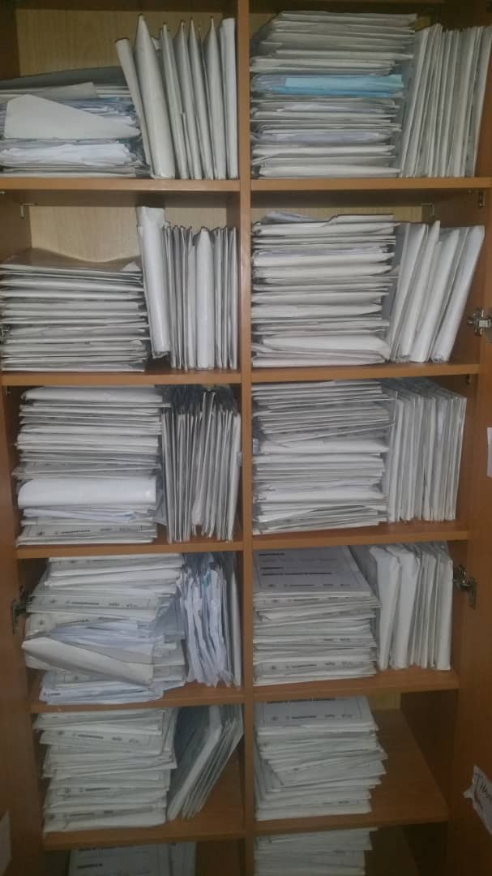

Sustainable Mechanism for Improving Livelihoods and Household Empowerment (SMILE)

Report Submitted: September 28, 2018

*This page is intentionally left blank.*

**Table of contents**

ACRONYMS V

1 EXECUTIVE SUMMARY 1

1.1 INTRODUCTION, PURPOSE AND METHODOLOGY 1

1.2 FINDINGS 2

1.3 Action PLANs 4

2 Introduction and purpose of the DQA 5

2.1 DATA QUALITY STANDARDS 6

2.2 OBJECTIVES OF THE DQA 6

2.3 INDICATOR ASSESSED 7

2.4 PERIOD OF THE DQA 7

2.5 THE SMILE ACTIVITY 8

3 METHODOLOGY 10

3.1 SAMPLING METHODOLOGY FOR SITE SELECTION 10

3.1.1 INCLUSION CRITERIA: 10

3.1.2 EXCLUSION CRITERIA: 11

3.2 SAMPLE SIZE 11

3.3 SELECTION OF BENEFICIARY FOLDERS AND FORMS FOR OVC INDICATOR REVIEW AT SITES 12

3.4 DATA COLLECTION FOR VALIDATION OF THE SELECTED INDICATOR 12

3.4.1 M&E SYSTEMS ASSESSMENT 13

3.4.2 DATA VERFICATION 13

3.4.3 DEFINITION AND INTERPRETATION OF THE VERIFICATION FACTOR 14

3.4.4. METHODOLOGY FOR CROSS-CHECKS AT CBO LEVEL 14

3.5 DQA TOOL 15

3.6 OTHER OPERATIONAL CONSIDERATIONS FOR DQAS 16

3.7 DATA ANALYSIS 16

4 FINDINGS 18

4.1 M&E SYSTEMS ASSESSMENT – SIX FUNCTIONAL AREAS 18

4.1.1 SMILE CENTRAL M&E UNIT 18

4.1.2 SMILE STATE-LEVEL M&E UNIT 20

4.1.3 SMILE SERVICE DELIVERY LEVEL (CBOs) 23

4.2 DATA QUALITY STANDARDS 26

4.2.1 VALIDITY 26

4.2.2 RELIABILITY 30

4.2.3 PRECISION 31

4.2.4 TIMELINESS 31

4.2.5 INTEGRITY 32

5 Action plan for SMILE 33

5.1 ACTION PLAN FOR SMILE CENTRAL LEVEL 33

5.2 ACTION PLAN FOR SMILE STATE LEVEL 34

5.3 ACTION PLAN FOR SMILE CBO LEVEL 35

6 Limitations and Constraints 36

7 Conclusions 37

8 Annexes 38

8.1 LIST OF SITES VISITED AND LOCATIONS: SMILE DQA 38

8.2 STEPS FOR DATA VERIFICATION USING THE MEASURE EVALUATION TOOL 38

8.3 VERIFICATION FACTORS – SMILE CENTRAL, STATE AND cbo LEVELS 39

8.4 DIAGRAMMATIC REPRESENTATION OF CROSS-CHECKS AT CBO LEVEL 42

8.5 DATA BACKUP MECHANISMS IN BENUE, EDO, NASARAWA AND FCT CBOs 43

8.6 PERFORMANCE INDICATOR REFERENCE SHEET (PIRS) 44

8.7 LIST OF DOCUMENTS, DATA, AND STANDARD OPERATING PROCEDURES REVIEWED 47

8.7.1 LIST OF SMILE DATA AND DOCUMENTS REVIEWED 47

8.7.2 LIST OF SMILE REPORTING TOOLS REVIEWED 47

8.7.3 LIST OF SMILE SOP/GUIDELINES AND OTHER DOCUMENTS REVIEWED 47

8.8 LIST OF INDIVIDUALS INTERVIEWED DURING THE SMILE DQA 48

**LIST OF TABLES**

*Table 1. Data Quality Standards and Operational Definitions* 6

*Table 2. Schedule for SMILE DQA* 8

Table 3. List of Central, State, and CBO Offices/Sites Visited for the SMILE DQA 11

*Table 4. Data Coverage for SMILE DQA, by Level* 12

*Table 5. Cross-Check Findings from SMILE CBOs in FCT, Edo, Benue and Nasarawa States* 29

*Table 6. Mechanisms for Ensuring Data Integrity across SMILE Sites* 32

*Table 7. Action Plan for SMILE Central Level* 33

*Table 8. Action Plan for SMILE State Level* 34

*Table 9. Action Plan for SMILE CBO Level* 35

Table 10. OVC_HIVSTAT Data at Central and State Levels 39

Table 11. OVC_HIVSTAT Verification Factors at the Central and State levels 39

Table 12. OVC_HIVSTAT Data at the CBO Level 40

Table 13. OVC_HIVSTAT Verification Factors at the CBO level 41

*Table 14. Data Backup Mechanisms Utilized Across SMILE Sites Visited* 43

*Table 15. List of Individuals Interviewed during the SMILE DQA* 48

**LIST OF FIGURES**

Figure 1: Data Management System Assessment for all SMILE sites visited – Global Average 3

*Figure 2. SMILE Coverage in Nigeria* 9

*Figure 3. Spider Graph of M&E Systems Assessment: SMILE Central M&E Unit* 19

*Figure 4. Spider Graph of M&E Systems Assessment: SMILE Benue State* 21

Figure 5: Spider Graph of M&E Systems Assessment: SMILE Edo State 22

*Figure 6. Spider Graph of M&E Systems Assessment: SMILE Nasarawa State* 22

Figure 7: Spider Graph of M&E Systems Assessment: SMILE FCT 22

Figure 8.SMILE Benue State OVC_HIVSTAT Numerator Total and Disaggregates 27

Figure 9. Verification Factors: OVC_HIVSTAT Numerator Total for SMILE CBOS 28

Figure 10. Data Verification by Level of Reporting System for SMILE 28

Figure 12. Reporting Performance – Results by State and Aggregate of States Result 31

*Figure 13. Tracing and Verifying Reported Totals: CBO via State to Central M&E Unit* 38

*Figure 14. Methodology for Cross-Checks at CBO Level* 42

# ACRONYMS

ADS Automated Directives System

ART Anti-Retroviral Therapy

CACA Catholic Action Committee on HIV/AIDS

CBCSP Community-Based Care and Support Program

CBO Community-Based Organization

CMP Change Management Process

FCTCRS Catholic Relief Services

CSO Civil Society Organization

CV Community Volunteers

CWYCA Centre for Women Youth and Community Action

DATIM Data for Accountability, Transparency, and Impact

DEC Data Entry Clerk

DHSP Department of Health Service Providers, Catholic Archdiocese of Benin

DQA Data Quality Assessment

EEFFH EFA-Eying Foundation for Family Health, Vandeikya

FAHCI Family Health Care Foundation

FCT Federal Capital Territory

GPI Girls Power Initiative

HIV/AIDS Human Immunodeficiency Virus/Acquired Immunodeficiency Syndrome

IHPCD Integrated Health Program Catholic Diocese of Makurdi

IM Implementing Mechanism

IP Implementing Partner

JDPC Justice Development and Peace Commission, Catholic Diocese of Uromi

LGA Local Government Authority (or Area)

LOPIN Local OVC Partners in Nigeria

M&E Monitoring and Evaluation

MEASURE Monitoring and Evaluation to Assess and Use Results

MEL Monitoring, Evaluation, and Learning Activity

MER Monitoring, Evaluation, and Reporting

MWASD Ministry of Women’s Affairs and Social Development

NOMIS National OVC Management Information System

OC Otabo Caregivers Otukpo

OGAC Office of the United States Global AIDS Coordinator

OVC Orphans and Vulnerable Children

OVC_HIVSTAT PEPFAR Indicator: Number of children less than 18 years with reported HIV status to implementing partner

OVC_SERV PEPFAR Indicator: Number of beneficiaries served by PEPFAR OVC programs for children and families affected by HIV

PEPFAR President’s Emergency Plan for AIDS Relief

PIRS Performance Indicator Reference Sheet

RDQA Routine Data Quality Assessment

SAPR Semi Annual Program Results

SCD Society for Community Development

SIDHAS Strengthening Integrated Delivery of HIV/AIDS Services

SMILE Sustainable Mechanism for Improving Livelihoods and Household Empowerment

SOP Standard Operating Procedure(s)

STEER Systems Transformed for Empowered Action and Enabling Responses for Vulnerable Children and Families

TWG Technical Working Group

UGM Umbrella Grant Mechanism (USAID)

USAID United States Agency for International Development

VC Vulnerable Children

# EXECUTIVE SUMMARY

## INTRODUCTION, PURPOSE AND METHODOLOGY

The United States Agency for International Development (USAID)/Nigeria technical offices regularly collect performance data from their Implementing Partners (IPs), and analyze it to make management decisions. Program management requires accurate, reliable, complete, and timely data to facilitate evidence-based decision making. Orphans and Vulnerable Children (OVC) programs among Human Immunodeficiency Virus/Acquired Immunodeficiency Syndrome (HIV/AIDS) affected populations provide need-based and age-appropriate socioeconomic interventions and require data that ensures provision of high-quality services. Since poor-quality data affect conclusions about performance and lead to incorrect decisions, USAID requires that all Missions/Offices conduct regular Data Quality Assessments (DQA), to review (1) strengths and weaknesses of the data, as determined by applying the five data quality standards (i.e., ***validity, reliability, timeliness, precision, integrity***); and (2) the extent to which the data integrity can be trusted in making management decisions.

The Sustainable Mechanism for Improving Livelihoods and Household Empowerment (SMILE) Activity is one of USAID/Nigeria’s OVC Implementing Mechanisms (IM) being implemented by the Catholic Relief Services (CRS). In 2017, USAID/Nigeria and the Monitoring, Evaluation, and Learning (MEL) Activity of DevTech Systems, Inc. conducted a joint DQA to validate six months of SMILE performance data for the period October 1, 2016, to March 31, 2017. The US President’s Emergency Plan for AIDS Relief (PEPFAR) indicator reviewed was the ***“number of OVCs served (OVC_SERV)”****,* as reported through the National OVC Management Information System (NOMIS). A follow-up DQA was conducted by the MEL Activity in March 2018 to assess the extent to which recommendations from the Fiscal Year (FY) 2017 DQA were executed and the challenges encountered in implementing the recommendations. Action plans were developed for quick execution of the follow-up DQA recommendations based on identified challenges.

In FY 2018, another DQA exercise was conducted to review performance data submitted by SMILE to USAID for the Semi-Annual Program Results (SAPR) period (October 1, 2017 to March 31, 2018) for the PEPFAR indicator “OVC_HIVSTAT”, which is the “Percentage of OVC less than 18 years old with HIV status reported to the IP (including status not reported), disaggregated by status type”. For this assessment, only the numerator “Number of OVC less than 18 years old with HIV status reported to the IP (including status not reported), disaggregated by status type was assessed because the denominator is no longer collected as part of the OVC_HIVSTAT indicator, it is collected as part of the OVC_SERV indicator.

The DQA was implemented using purposive sampling methodology in twelve selected Community Based Organizations (CBOs) in Benue, Edo, Nasarawa and the Federal Capital Territory (FCT), the respective SMILE state offices, and the SMILE central Monitoring and Evaluation (M&E) unit in Abuja, FCT.

The DQA methodology at all levels included: (1) A review of activity M&E documents, materials, and data, including Standard Operating Procedures (SOP), guidelines, Performance Indicator Reference Sheet (PIRS), and other guiding documents for organizational M&E management, data management, and processing; (2) A review of six months of SMILE OVC summary reports, and trace and verification of indicator data (including NOMIS data); (3) A review of a subset of source documents (beneficiary forms and household folders), and entries of beneficiaries and households in the NOMIS; (4) Interviews with M&E Officers and personnel; (5) Cross-checks across systems and records; (6) A review of the data applying the five data quality standards (i.e., validity, reliability, integrity, precision, timeliness); and (7) A debrief at each site on the preliminary DQA findings using a feedback form. The DQA team utilized the USAID MEASURE Evaluation’s DQA Excel Tool (RDQA multi-indicator version[1]), as well as the USAID data quality checklist[2] to assess the data quality standards.

## FINDINGS

**M&E Systems Assessment**

SMILE Central M&E Unit: *Strengths*: (1) Availability of trained M&E staff; (2) Capacity building opportunity for SMILE M&E staff through the CRS LEARNS platform; (3) Clear responsibilities for the review of data at the central level are assigned to the M&E Director; (4) SOP on data management was available and in use; and (5) The national database (NOMIS) was used for data reporting. *Areas for Improvement*: (1) SOP for data management does not include guidelines on the storage period of source documents; and (2) Limited data demand and use. *Recommendations*: (1) Develop guidelines for inclusion in the data management SOP to inform the storage period of source documents; and (2) Develop guidelines on data demand and use and ensure its implementation across all levels.

SMILE State M&E Units: *Strengths*: (1) All State-level M&E Officers have received relevant training to carry out their assigned responsibilities; (2) The PIRS for the indicator and data management SOP were available and in use to guide activity implementation; and (3) Use of data for decision making in Benue and Nasarawa states. *Areas for Improvements:* (1) SMILE staff at the FCT office were not aware of the period required to store source documents; (2) Little or no evidence of data use in Edo and the FCT. *Recommendations:* (1) Obtain guidelines on storage period of source documents from the central office for use; and (2) Build the capacity of the Edo and FCT SMILE M&E Officers to analyze and use data for decision making.

SMILE CBOs: *Strengths*: (1) CBOs use a variety of methods to minimize data quality issues and prevent double counting; (2) Non-M&E staff members of CBOs fill in the gap for the M&E Officer when unavailable; (3) Availability and use of PIRS and SOP to guide activity implementation; (4) Data are analyzed and disseminated to various stakeholders. *Areas for Improvement:* (1) Older version of PIRS was being used in the following CBOs: Girls Power Initiative (GPI), Department of Health Service Providers (DHSP) and Catholic Action Committee on HIV/AIDS, Archdiocese of Abuja (CACA); (2) Guideline on the storage period of store source document was not available in the following CBOs: Justice Development and Peace Commission, Catholic Diocese of Uromi (JDPC), Society for Community Development (SCD) and Elohim foundation; (3) Improper arrangement of client service forms within the folders and folders within the storage cabinets made retrieval of beneficiary information difficult at the following CBOs: Centre for Women Youth and Community Action (CWYCA), Family Health Care Foundation (FAHCI) and Community-Based Care and Support Program, Catholic Diocese of Lafia (CBCSP); and (4) Confidentiality of beneficiary information was not properly maintained in the following CBOs because client folders are stored in an open filing cabinet within a room with no locks : Integrated Health Program Catholic Diocese of Makurdi (IHPCD) and EFA-Eying Foundation for Family Health, Vandeikya (EEFFH). *Recommendations:* (1) Ensure all CBOs have and use the PEPFAR Monitoring, Evaluation and Reporting (MER) indicator guide version 2.2; (2) SMILE Central office staff should develop and disseminate guidelines to inform the storage period of source documents; (3) Build the capacity of CBOs to appropriately file client records within each household folder for easy retrieval; (4) Build the capacity of CBOs to appropriately arrange files vertically within the storage cabinets for ease of retrieval; (5) Provide filing cabinets with adequate storage space for CBOs and ensure they have functional locks.

The general findings on the M&E system assessment for all SMILE levels assessed are shown in the spider web graph in Figure 1. The general areas for improvement for SMILE are in data management processes and use of data for decision making. The section on links with the national reporting system shows some gaps which is as a result of parallel reporting channels i.e., to government and donor agencies. However, there is mechanism in place to harmonize data at the different levels such as such as the OVC program Technical Working Group (TWG) meetings with OVC IPs at the federal and state levels, during which attempts are made to harmonize OVC data across board to avoid double-counting of OVC beneficiaries.

Figure 1: Data Management System Assessment for all SMILE sites visited – Global Average

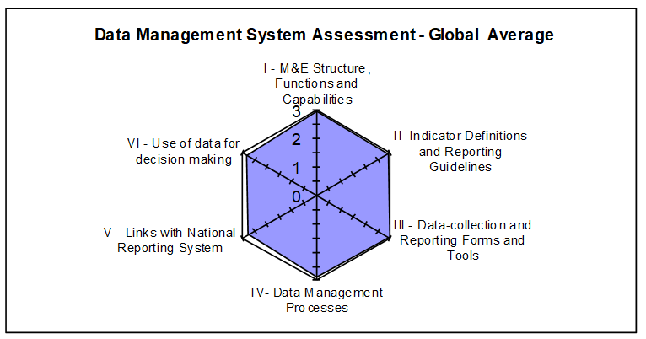

**Data Quality Standards**

Validity*:* *Strengths:* (1) The data collection process adheres to the PIRS requirements; (2) The “HIV status update form” on the NOMIS is used to input and update the HIV status of the beneficiaries for accurate reporting; and (3) Data are reported consistently in all CBOs for vulnerable children less than18 years, disaggregated by their HIV status. *Areas for Improvement:* (1) There were incomplete entries in the source documents, and transcription errors were observed in the NOMIS; and (2) Errors were observed during data verification. *Recommendations:* (1) Improve supervisory efforts to CBOs to ensure accurate data entry and proper use of the NOMIS; and (2) Conduct refresher training for Data Entry Clerks (DEC) on the NOMIS software.

Reliability*:* *Strengths*: (1) National OVC reporting tools were consistently used during the reporting period; (2) All CBO staff have been trained on the updated OVC tools and none experienced stock out of tools during the period under review. *Areas for Improvement:* None. *Recommendations:* None.

Precision*:* *Strengths*: (1) The NOMIS has individual-level data, providing sufficient detail and precision on number of children less than 18 years with HIV status reported to the IP; (2) The level of precision in the data collection tools and in the NOMIS matches the requirements in the PIRS; and (3) Data from service forms are entered in the NOMIS in a consistent manner using all nationally approved data fields. *Areas for Improvement:* None. *Recommendations:* There were no specific recommendations in connection with data precision.

Timeliness*:* *Strengths*: (1) Data reporting from CBO level upward is via electronic means, via NOMIS and is reported to be received in a timely manner at higher levels. *Areas for Improvement:* (1) Late submission of reports in Benue (four reports), Edo (four reports) and Nasarawa (fourteen reports). *Recommendations:* Ensure CBO compliance to reporting timelines.

Integrity*:* *Strengths:* (1) Data quality assurance and management at the central and state levels are through: the use of the NOMIS software which has password access for confidentiality and built-in error and quality checks; visits to lower levels for supervision and to conduct data quality checks; and the use of email and phone call communication by the M&E staff; and (2) Data review meetings are held quarterly during which data quality issues are addressed. *Areas for Improvement:* (1) Use of pencils to complete service forms in SCD. *Recommendations* (1) The SMILE state office staff should ensure CBOs discontinue the use of pencils when filling service forms.

## Action PLANs

*Central Level*: The SMILE central M&E team are recommended to implement the following action points to improve the M&E system and data quality: (1) Develop guidelines for inclusion in the data management SOP to inform the storage period of source documents; (2) Develop guidelines on data demand and use and ensure its implementation across all levels; and (3) Build the capacity of the Edo and FCT M&E team to analyze and use data for decision making.

*State Level*: The SMILE state M&E team are recommended to implement the following action points to improve the M&E system and data quality: (1) Disseminate the most updated version of the PEPFAR MER indicator reference guide version 2.2 to all CBOs and ensure compliance of CBOs to its use; (2) Provide guidelines and technical assistance to CBOs on the proper filing system of beneficiary folders (vertical arrangement) and service forms to aid quick retrieval of client records; (3) Improve supervisory efforts with the CBOs to ensure accurate data entry and proper use of the NOMIS; (4) Conduct refresher training for DECs on the NOMIS software; (5) Conduct refresher training for CBOs on the correct calculation of data elements for reporting on the OVC_HIVSTAT based on the updated indicator reference guide; (6) Ensure compliance of CBOs to reporting timelines; and (7) Improve supervisory efforts to CBOs to ensure staff discontinue use of pencils in filling source documents.

*CBO Level*: The LOPIN 2 CBOs are recommended to implement the following action points to improve the M&E system and data quality: (1) Improve supervisory efforts to DECs to improve accuracy of data entry into the NOMIS and of reported data to SMILE state office. (2) Provide adequate storage space for beneficiary folders at GPI (3) Provide storage space with lock and key for beneficiary folders at IHPCD; and (4) Engage a vendor to repair damaged filing cabinet at EFFH.

# Introduction and purpose of the DQA

The technical offices of the United States Agency for International Development (USAID)/Nigeria regularly collect performance data from their Implementing Partners (IPs), and analyze it to make management decisions. Program management requires accurate, reliable, complete, and timely data to facilitate evidence-based decision-making and, ultimately, to ensure efficient and effective program implementation. Orphans and Vulnerable Children (OVC) programs among populations affected by Human Immunodeficiency Virus/Acquired Immunodeficiency Syndrome (HIV/AIDS) provide socioeconomic interventions that are need based and age appropriate, and therefore require data to ensure that high-quality services are provided to children and their families. This is even more important in households with an HIV-positive child or caregiver, who will need to receive the appropriate support to access care, treatment, and other related services. Since poor-quality data could affect conclusions about performance and lead to incorrect decisions, USAID requires that all Missions/Offices conduct regular Data Quality Assessments (DQA).

The Automated Directives System (ADS) contains the organization and functions of USAID, along with the policies and procedures that guide the Agency's programs and operations. As described in ADS 201, the purpose of a DQA is to ensure that the USAID Missions are aware of the:

1. Strengths and weaknesses of the data, as determined by applying the five data quality standards (Table 1 below, page 6); and
2. Extent to which the data integrity can be trusted in making management decisions. (ADS 201.3.5.8).

One of the primary purposes of the DQA presented in this report is to meet the ADS-related requirements of USAID/Washington and the USAID/Nigeria technical offices. A DQA also serves to review the Monitoring and Evaluation (M&E) system, supports the identification of best practices, and develop recommendations to improve existing systems, for better reporting of activity-level indicators in subsequent funding cycles.

The President’s Emergency Plan for AIDS Relief (PEPFAR) Nigeria implements its OVC activities through community-based partners and, in some cases, through comprehensive treatment partners who provide some OVC services. Most OVC Implementation Mechanisms (IMs) work through Community-Based Organizations (CBOs) that work directly with the communities, although in some cases IPs conduct direct implementation to beneficiaries. Performance results are reported semi-annually based on the Office of the Global AIDS Coordinator (OGAC) requirements, and quarterly based on USAID requirements.

A joint DQA was conducted in the month of June 2018 by the Monitoring, Evaluation and Learning (MEL) Activity of DevTech Systems, Inc. and USAID/Nigeria, to validate six months of performance data generated through Sustainable Mechanism for Improving Livelihoods and Household Empowerment (SMILE), one of USAID/Nigeria’s OVC IMs being implemented by Catholic Relief Services (CRS). The DQA was for the “OVC_HIVSTAT” PEPFAR indicator, as reported through the National OVC Management Information System (NOMIS) between October 1, 2017 and March 31, 2018, the (Semi-Annual Program Results [SAPR] reporting period). The SMILE OVC DQA was conducted in a total of twelve selected CBOs: three in Benue, three in Edo, three in Nasarawa, and three in the Federal Capital Territory (FCT), using a purposive sampling methodology, with guidance from USAID/Nigeria.

## DATA QUALITY STANDARDS

Table 1 lists the five data quality standards that are central to a data quality assessment, especially in the context of USAID-funded activities.

*Table 1. Data Quality Standards and Operational Definitions*

|  |  |
| --- | --- |
| **Data Quality Standard** | **Operational Definition** |
| **Validity** | Data are valid to the extent that they clearly, directly and adequately represent the result that was intended to be measured. Measurement errors, unrepresentative sampling and simple transcription errors may adversely affect data validity. Data should be periodically tested to ensure that no error creates significant bias. |
| **Reliability** | Data reflect stable and consistent data collection processes and analysis methods over time. Activity managers are confident that progress toward performance targets reflects real changes rather than variations in data collection methods. Reliability can be affected by questionable validity as well as by changes in data collection processes. |
| **Timeliness** | Data are available with enough frequency and should be sufficiently current to inform management decision-making. Effective management decisions depend upon regular collection of up-to-date performance information. |
| **Precision** | Data should be sufficiently accurate to present a fair picture of performance and enable activity managers to make confident decisions. |
| **Integrity** | Data that are collected, analyzed and reported should have a mechanism in place to reduce the possibility that data are subject to erroneous or intentional alteration. |

Source: ADS 201. Data Quality Assessment Standards.

## OBJECTIVES OF THE DQA

In addition to the overall purpose of the DQA mentioned in ADS 201, the specific objectives of the DQA are:

1. To verify that the quality of data reported from October 1, 2017 to March 31, 2018 for the OVC_HIVSTAT indicator in the SMILE IM (section 2.5, page 8), are grounded in the components of data quality.
2. To ensure that managers can use data generated to effectively direct available resources, and to evaluate progress toward established goals.
3. To assess and identify potential challenges to data quality created by the data management and reporting systems at three levels:

* The Activity’s central M&E unit;
* The intermediary aggregation level (state); and
* The service delivery level (CBO office in the Local Government Area [LGA]).

1. To develop action plans to improve weaknesses and gaps identified in the levels above.

## INDICATOR ASSESSED

The selection of the indicator for assessment was based on technical guidance from USAID/Nigeria and the fact that OVC_SERV was assessed in 2017 for the IM. The indicator assessed during this round of DQA exercise is the OVC_HIVSTAT indicator which is defined according to the PEPFAR Monitoring, Evaluation and Reporting (MER) 2.0 Indicator Reference Guide Version 2.2. as the “**Percentage of orphans and vulnerable children (less than 18 years old) with HIV status reported to implementing partners (including report of no status).”** This indicator formerly called OVC_ACC (MER1.0) and OVC_KNOWSTAT (in the original MER 2.0 target setting documentation guidance) was changed to OVC_HIVSTAT to reflect that HIV is self-reported to the IP by the OVC or OVC caregiver (MER 1.0 to MER 2.0). The Performance Indicator Reference Sheet (PIRS) for the indicator defines its dimensions and description (Annex section 8.6). This indicator is calculated from data elements in the NOMIS.

Numerator: Number of orphans and vulnerable children (less than 18 years old) with HIV status reported to implementing partner, disaggregated by status type.

Denominator: This is not collected again as part of the indicator but is collected under the indicator OVC_SERV. It is the number of orphans and vulnerable children reported under OVC_SERV (less than 18 years old).

Disaggregation:

* Reported as HIV positive to the IP:
  + Currently receiving Anti-Retroviral Therapy (ART)
  + Not currently receiving ART
* Reported as HIV negative to IP
* Reported with no HIV infection to the IP:
  + HIV test not indicated based on HIV risk assessment
  + Other reasons

Data Sources for the indicator include vulnerable children (VC) enrolment form, VC service form, VC follow-up form, HIV test results, registers and program data generated by IPs. All the forms have the names of children and their HIV status to generate the number included in this indicator.

Reporting level for the indicator includes site level, facility and community, and the reporting timeframe is semi-annual.

## PERIOD OF THE DQA

The DQA covered the USAID Semi Annual Program Results (SAPR) period, which comprises two quarters—i.e., October 1, 2017 to December 31, 2017, and January 1, 2018 to March 31, 2018. The schedule for the DQA by state is shown below in Table 2.

*Table 2. Schedule for SMILE DQA*

|  |  |  |
| --- | --- | --- |
| **IM** | **Level** | **Date of DQA** |
| SMILE | Central Level DQA | June 11, 2018 |
| Aggregation and service delivery levels in Benue State | June 11-13, 2018 |
| Aggregation and service delivery levels in Edo State | June 12-14, 2018 |
| Aggregation and service delivery levels in FCT | June 12-14, 2018 |
| Aggregation and service delivery levels in Nasarawa State | June 25 - 27, 2018 |

## THE SMILE ACTIVITY

SMILE is a five-year (2013–2018) activity funded by USAID/Nigeria’s Umbrella Grant Mechanism (UGM). Catholic Relief Service (CRS) Nigeria, which leads the SMILE consortium which also consists of ActionAid Nigeria and Westat. The Activity is implemented in the FCT, Benue, Kogi, Edo, and Nasarawa states and is aimed at scaling-up care and support services for OVC and their households. The Activity is implemented through CBOs to ensure coordinated provision of quality services in a sustainable manner. The SMILE CBOs provide enrollees, caregivers, and households with the following targeted services:

* Psychosocial services;
* Health and Nutritional services;
* Educational services;
* HIV Care, Treatment and Childhood Tuberculosis (TB);
* Child Protection services; and
* Household Economic Strengthening (HES) services.

The goal of the SMILE activity is to reach 600,000 children and 150,000 caregivers across its five activity states over a five-year period. The activity works with fifty-two CBOs in forty-eight LGAs in the five states (Figure 2). In addition, SMILE has embedded staff in the Ministry of Women Affairs and Social Development (MWASD) in all the activity states to lead its government’s system strengthening intervention. The staff work directly with the staff of the OVC Division in the Ministry to strengthen their skills in coordinating the state’s OVC response, including oversight of Civil Society Organization (CSO) activities and networks working in child protection systems strengthening, child rights advocacy and access to justice for rights violation. The Activity which was to end in March 2018 initially was extended by USAID until September 2018. This is the second external DQA undertaken for SMILE.

*Figure 2. SMILE Coverage in Nigeria*

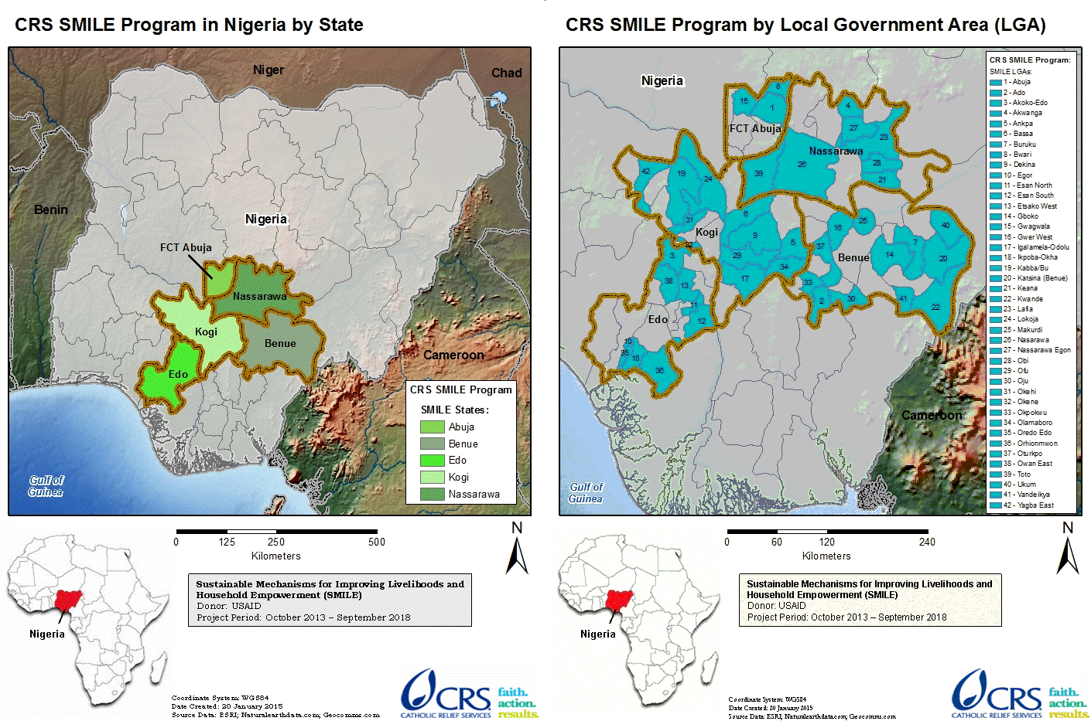

Source: SMILE Activity Nigeria website (https://smileprojectnigeria.crs.org/)

# METHODOLOGY

The DQA methodology included the following steps:

1. Desk review of activity documents, materials, and data, including:

* The organization’s Standard Operating Procedures (SOP), guidelines, PIRS for the indicator, and other guiding documents for organizational M&E management, data management, and processing;
* Six months (October 1, 2017 to March 31, 2018) of SMILE performance data for the PEPFAR indicator “OVC_HIVSTAT” as calculated using data elements within the NOMIS;
* State-level summary reports for the reporting period defined above; and
* Entries of beneficiaries and their households in NOMIS.

2. Key informant interviews and focus group discussions with members of the SMILE M&E team at all levels. Since only one M&E focal person or staff was usually available in the field, the majority of M&E systems assessments were conducted as key informant interviews.

3. Trace and verification of reported data with cross-checks across systems and records, including review of beneficiary folders and service forms.

4. Review of the five data quality standards (validity, reliability, integrity, precision and timeliness).

It must be noted that in some instance a household folder may contain more than one beneficiary service form, since a beneficiary can be served multiple times in a span of six months, and there may be more than one eligible beneficiary per household.

## SAMPLING METHODOLOGY FOR SITE SELECTION

A purposive sampling technique was used for the selection of DQA sites. This was based on USAID/Nigeria’s guidance and also based on the fact that DQAs for six OVC IMs were concurrently implemented during the period of the exercise: SMILE, STEER (Systems Transformed for Empowered Action and Enabling Responses), LOPIN 3 (Local OVC Partners in Nigeria 3), LOPIN 2 (Local OVC Partners in Nigeria 2), LOPIN 1 (Local OVC Partners in Nigeria 1) and SIDHAS (Strengthening Integrated Delivery of HIV/AIDS Services).

The selection criteria used are as follows:

### INCLUSION CRITERIA:

* LGAs where USAID-supported OVC activities are actively being implemented by SMILE;
* LGAs which reported results for the OVC_HIVSTAT indicator for FY 2018 SAPR (October 1, 2017-March 31, 2018); and
* LGAs visited or within close proximity to those visited during the USAID/Nigeria SMILE FY 2017 DQA exercise for the OVC_SERV indicator.

### EXCLUSION CRITERIA:

* Sites located in high security level states, ranked at level four or for which access to the state requires passage through a level four state; and
* Sites located in a difficult, hard to reach terrain.

## SAMPLE SIZE

The IP’s central office, four IP state offices (Benue, Edo, Nasarawa and the FCT) and twelve CBOs (service delivery sites) were selected based on the criteria outlined above and visited for the DQA exercise. Table 3 below provides the complete list of sites selected and visited for the DQA exercise.

Table 3. List of Central, State, and CBO Offices/Sites Visited for the SMILE DQA

|  |  |  |  |  |
| --- | --- | --- | --- | --- |
| **S. NO** | **LEVEL** | **NAME OF OFFICE / SITE** | **STATE/LGA** | **DATE OF VISIT** |
| 1 | Central M&E Unit | Catholic Relief Services (CRS) office | Abuja | 11 June, 2018 |
| 2 | Aggregation level | SMILE State Office | Benue | 11 June, 2018 |
| 3 | Aggregation level | SMILE State Office | Edo | 13 June, 2018 |
| 4 | Aggregation level | SMILE State Office | Nasarawa | 25 June, 2018 |
| 5 | Aggregation level | SMILE State Office | FCT | 11 June, 2018 |
| 6 | Service Delivery level | Justice Development and Peace Commission (JDPC), Catholic Diocese of Uromi | Edo/Esan North East | 12 June, 2018 |
| 7 | Service Delivery level | Girls Power Initiative (GPI) | Edo/Oredo | 14 June, 2018 |
| 8 | Service Delivery level | Department of Health Service Providers (DHSP), Catholic Archdiocese of Benin | Edo/Ikpoba-Okha | 14 June, 2018 |
| 9 | Service Delivery level | Catholic Action Committee on HIV/AIDS (CACA), Archdiocese of Abuja | FCT/Bwari | 13 June, 2018 |
| 10 | Service Delivery level | Society for Community Development (SCD) | FCT/AMAC | 14 June, 2018 |
| 11 | Service Delivery level | Elohim Foundation | FCT/Gwagwalada | 12 June, 2018 |
| 12 | Service Delivery level | Centre for Women Youth and Community Action (CWYCA) | Nasarawa/Nasarawa Eggon | 25 June, 2018 |
| 13 | Service Delivery level | Family Health Care Foundation (FAHCI) | Nasarawa/Lafia | 27 June, 2018 |
| 14 | Service Delivery level | Community Based Care and Support Program, Catholic Diocese of Lafia (CBCSP) | Nasarawa/Akwanga | 26 June, 2018 |
| 15 | Service Delivery level | Integrated Health Program, Catholic Diocese of Makurdi (IHPCD) | Benue/Makurdi | 11 June, 2018 |
| 16 | Service Delivery level | Otabo Caregivers (OC) Otukpo | Benue/Otukpo | 13 June, 2018 |
| 17 | Service Delivery level | EFA-Eying Foundation for Family Health (EFFH), Vandeikya | Benue/Vandekiya | 12, June, 2018 |

Staff with OVC M&E responsibilities were interviewed for the M&E systems assessment across all the three levels. A complete list of personnel interviewed at various levels is provided in the Annex section 8.8, Table 15. From the perspective of coverage for data verification, a major strength was that 100% of aggregate data records were reviewed at the central, state, and CBO levels (Table 4).

*Table 4. Data Coverage for SMILE DQA, by Level*

|  |  |  |
| --- | --- | --- |
| **Data Coverage for SMILE OVC DQA, by Level** | | |
| **Level / Location** | **Data Format(s)** | **Sample Covered for Data Verification** |
| Central M&E unit | Electronic (NOMIS) | All records / 100% |
| Four IP State Offices (FCT, Edo, Benue and Nasarawa) | Electronic (NOMIS) | All records / 100% |
| Service Delivery Level / CBO | Electronic (NOMIS) | All records / 100% |
| Service Delivery Level (Cross-Checks on Source Documents) | Electronic (NOMIS) and paper (beneficiary forms and folders) | 20 per CBO:  10 forward cross-checks – folder/form to the NOMIS, and  10 reverse cross-checks – the NOMIS to folder/form.  The average number of eligible forms reviewed per folder was about 5. |

## SELECTION OF BENEFICIARY FOLDERS AND FORMS FOR OVC INDICATOR REVIEW AT SITES

To ensure adequate time for the DQA team to complete all aspects of the DQA—including the M&E systems assessment, review of the data quality standards, data verifications, and cross-checks—the DQA team reviewed at least ten beneficiary folders (randomly selected, where feasible) for the service period between October 1, 2017 to March 31, 2018. All the beneficiaries in each of the ten service folders which are less than 18 years were selected for cross-checks between the beneficiary service forms and the NOMIS. It must be noted that an OVC beneficiary household folder often contains more than one beneficiary service form; a beneficiary can be served multiple times in a span of six months, and there may be more than one eligible beneficiary per household. An additional ten unique beneficiary records from the NOMIS were traced back to the beneficiary folders for further cross-verification. Details of the methodology for sampling (including random selection) and cross-checks are provided in section 3.4.4 and Annex section 8.4 (Figure 13).

## DATA COLLECTION FOR VALIDATION OF THE SELECTED INDICATOR

Three processes were utilized to collect data for validation of the OVC_HIVSTAT indicator reported by SMILE. They include:

1. An M&E systems assessment, administered at each level of the data collection and reporting system, i.e., central M&E unit, state level, and CBOs (service delivery level);
2. Verification of reported data for the OVC_HIVSTAT indicator; and
3. Review of the five data quality standards (validity, reliability, integrity, precision and timeliness).

### 3.4.1 M&E SYSTEMS ASSESSMENT

The M&E systems assessment evaluated the data management and reporting system, including off-site review of documents provided by SMILE, and on-site follow-up assessment at the SMILE central M&E unit, four state IP offices and selected CBOs.

### 3.4.2 DATA VERFICATION

At the central IP level, documents were reviewed for availability, timeliness, and completeness of expected reports from the aggregate levels/IP state offices for the selected reporting period.

At the intermediate/IP state offices, the DQA team carried out the following steps to verify the data:

1. Document review: The DQA team reviewed availability, timeliness, and completeness of expected reports from service delivery sites for the selected reporting period.
2. Verifying reported numbers: To verify reported numbers, the DQA team:
   1. Re-aggregated the numbers submitted by the service delivery sites;
   2. Compared the verified counts to the numbers submitted to the next level (central IP M&E unit); and
   3. Identified reasons for any differences.

The data verification at the service delivery/CBO sites involved the following processes:

1. Observation and description: This process involved the DQA team’s observation and description of the connection between the delivery of OVC services and the completion of the source document (beneficiary form) to record the HIV status of beneficiaries.
2. Review of source documents: The DQA team reviewed the availability and completeness of the OVC_HIVSTAT indicator source documents. At least 20 beneficiary records (randomly selected where feasible) for the selected reporting period were reviewed for the record of their HIV status.
3. Recounting reported results: This involved:
4. Reported numbers of OVCs less than age 18 with their HIV status reported to SMILE were recounted from available source documents (beneficiary forms);
5. The above numbers were compared and verified with the figures for OVC less than age 18 with reported HIV status from NOMIS for the period of review (October 1, 2017 to March 31, 2018); and
6. Reasons for any differences were identified and probed to determine if the differences were related to or impacted data quality standards.
7. Cross-checks were performed from beneficiary forms to the corresponding NOMIS entries, and vice versa. Spot checks will not be carried out to verify actual delivery of OVC services to the target population in order to protect beneficiary confidentiality.

During the data verification, SMILE-reported results on the NOMIS for OVC_HIVSTAT for each CBO from October 1, 2017 to March 31, 2018 were captured using a Microsoft Excel template. At each CBO, assessors reviewed relevant registers, folders and summary forms to verify the quality of data, to generate actual achievement for the indicator.

### 3.4.3 DEFINITION AND INTERPRETATION OF THE VERIFICATION FACTOR

#### 3.4.3.1 DEFINITION OF VERIFICATION FACTOR

For a specific site, the verification factor is the ratio of verified count (recounted by the DQA team from source documents) to the reported count (from the summary report prepared by the site) for a specific reporting period. It is usually expressed as a percentage. Mathematically, it can be expressed as:

Verification Factor (VF) = (Verified count at selected site / Reported count at selected site) x 100

#### INTERPRETATION OF THE VERIFICATION FACTOR

Verification factors greater than 100 percent indicate under-reporting (i.e., the source documents show a higher actual count than the numbers reported in the site summary), while verification factors less than 100 percent indicate over-reporting (i.e., the source documents show a lower actual count than the numbers reported in the summary). Both of these scenarios indicate a validity issue for data quality. A variance of less than ten percent in either direction is usually considered a minor issue. However, from the donor/funding perspective, under-reporting leads to under-estimation of the impact of the activity, while systematically high levels of over-reporting not due to errors can lead to questions about the accuracy of the data reporting system.

### METHODOLOGY FOR CROSS-CHECKS AT CBO LEVEL

Cross-checks were performed between beneficiary folders and the NOMIS in two directions:

Cross-check A: From beneficiary folders and corresponding beneficiary service forms to the NOMIS; and

Cross-check B: From the NOMIS to beneficiary folders and corresponding beneficiary service forms.

The DQA team sampled of beneficiary folders (randomly selected where feasible) to ensure adequate representation of the complete data available, with a minimum of ten folders selected, and adifferent set of beneficiary folders for each direction of cross-checks. Depending on the total number of folders at the CBO, at a minimum every **n**th folder was selected (where **n**=total number of folders divided by ten). The details of the cross-check methodology are provided below.

#### 3.4.4.1 Cross-check A: From beneficiary folders (and beneficiary service forms) to NOMIS

* Using the selection methodology described above, the DQA team selected at least ten beneficiary folders containing five or more corresponding beneficiary service forms with unique identifiers and enrollment numbers for an OVC service provided in the reporting period.
* The team confirmed that each of the five or more service forms were complete in the ten folders, indicating HIV status of the OVCs served in the reporting period and the OVC service provided**.** If any of the forms were incomplete, the relevant details were noted.
* Using the identifying enrollment number/unique identifier on the service form, the beneficiary was traced in the NOMIS to confirm if the corresponding entry existed, and if the basic details (ID, age, sex, etc.) were correct.

#### 3.4.4.2 Cross-check B: From NOMIS to beneficiary service form

* Using the sampling methodology described earlier (including random selection where feasible), the DQA team selected a different set of at least ten unique identifiers and enrollment numbers for OVCs less than age 18 served in the NOMIS for the reporting period.
* Using the identifying enrollment number/unique identifier in the NOMIS, the team traced and verified the beneficiary on the service form in the corresponding folder to confirm if the details were correct. The enrolment forms were also reviewed for completeness.

A diagrammatic depiction of cross-checks is provided in Figure 13 (Annex section 8.4).

## DQA TOOL

The MEASURE Evaluation multi-indicator routine DQA tool (2015)[3] guided the M&E system assessment and data verification processes. The MEASURE Evaluation multi-indicator routine DQA tool (2015) was used instead of the MEASURE Evaluation Single Indicator Routine DQA Tool (2010) because the multi-indicator tool assesses six components of the M&E system of the indicator while the single indicator DQA tool assesses only five. The DQA team utilized the multi-indicator tool to measure the following:

1. Strength of the data management and reporting system, for the indicator based on a review of the activity’s data collection and reporting system, including responses to questions on how well the system is designed and implemented.
2. Accuracy of reported data through the calculation of verification factors (i.e., the ratio of the recounted value of the indicator to the reported value) for the indicator "OVC_HIVSTAT" from October 1, 2017 to March 31, 2018, based on data verification performed at each level of the reporting system. This included:
   1. Number of OVC less than age 18 with HIV status reported at CBO level accurately reported in NOMIS;
   2. Cross-checks: Number of OVCs less than age 18 with HIV status validated from source documents (i.e., enrolment forms, service form and follow up form);
   3. Percentage of data reports from all participating CBOs in a state accurately reported at the state level; and
   4. Percentage of data reports from all participating SMILE states in Nigeria accurately reported at the central level.
3. Availability, completeness, and timeliness of reports through percentages calculated at the CBO, the state, and the central M&E unit.

The DQA team used the ADS 201 USAID-recommended DQA checklist[4] to review of the five data quality standards - validity, reliability, timeliness, precision and integrity of the data. Information needed to complete the USAID DQA checklist were already contained in the RDQA tool but the DQA team also probed for more information for areas that were not adequately covered by the RDQA tool.

## OTHER OPERATIONAL CONSIDERATIONS FOR DQAS

In conducting DQAs, the focus is on the indicator, not on the IP or the IM. For this DQA exercise, the DQA team assessed the OVC_HIVSTAT indicator as a whole, including all component parts, among the various partners who collect data for the indicator. The numerator disaggregates of the OVC_HIVSTAT indicator were also assessed. The level of consistency —whether different IPs collect and report the same indicator data when compared to one another—was a key finding.

During desk review and training, the DQA team examined the PEPFAR MER 2.0 indicator reference guide which contains the PIRS for the indicator. The team also reviewed key aspects about indicator data quality before site visits. When the DQA team met with the SMILE team, the DQA team assessed the PIRS for the indicator contained in the SMILE Activity Monitoring, Evaluation and Learning Plan (AMELP). The DQA team obtained information from the SMILE team regarding their definition of the indicator, methodology used to collect data for the indicator, and other questions to confirm if the team at SMILE understood the indicator as USAID intended it to be understood. The DQA team also asked the SMILE team whether they had a PIRS for the indicator and compared it to the USAID Mission’s “master” PIRS (PEPFAR MER 2.0 indicator reference guide). This was to ensure a match, and to determine if customizations might affect the data, or were just specifications to add clarity and detail pertaining to SMILE and did not alter the consistency of the data. Documentation in the PIRS includes any limitations to the data, a determination of whether the data are deemed to be of sufficient quality to be reported externally, any migration or other plans of action needed (including more frequent DQAs), as well as the expected date of the next DQA.

During the field work, in order to allay initial apprehensions of the IP and their staff, the DQA team emphasized to the IP that a Data Quality Assessment differs from a Data Quality Audit, although both are abbreviated in the same manner (through the acronym DQA). The team also highlighted the intention to use the DQA results as a ‘learning tool’ for USAID and the IP to work together to resolve any data quality After field-based work, the DQA team debriefed the IP of preliminary DQA findings using a feedback form. Depending on the inconsistencies and/or areas for improvement identified, the team provided feedback and solutions, mitigating actions, and, as appropriate, solicitation of suggestions from the IP and USAID.

## DATA ANALYSIS

Data were entered, processed, and analyzed using the MEASURE Evaluation tool and Microsoft Excel. Information were presented using charts, maps, tables, and spider graphs (cobweb). Descriptive statistics such as range, frequencies, mean, and percentages were used to describe and summarize DQA data verification findings. Since a purposive sampling was used for site selection, statistical summaries were presented only in the context of the sampled beneficiaries and may not be fully representative of the beneficiary population. The selected MER indicator, OVC_HIVSTAT, was scored and measured using all available numbers reported for the indicator, to determine if CBO data was valid as reported in NOMIS. Qualitative reasons for discordance between CBO data and NOMIS (over-reporting/under-reporting) or concordance (validated) as reported in NOMIS were summarized. As per the guidelines incorporated in the Measure RDQA tool, verification factors of +/- ten percent were considered to be marginal when reporting on the validity of the IP reported data.

.

# FINDINGS

## M&E SYSTEMS ASSESSMENT – SIX FUNCTIONAL AREAS

### SMILE CENTRAL M&E UNIT

#### M&E STRUCTURE, FUNCTIONS, AND CAPABILITIES

The SMILE central M&E unit has a documented organizational chart which was sighted but not displayed in the M&E unit. At the central level, there is a Director M&E, and he is supported by an M&E Officer (for the FCT area) and an M&E Assistant. SMILE encourages capacity building amongst its M&E staff and has developed a learning platform for all M&E staff called “CRS LEARNS”. Through this platform, it is mandatory that at least once in a year, every M&E staff attend a training course, either on-line, in-house or within an institution and CRS sometimes covers the expenses for the course.

The M&E Director is responsible for reviewing the quality of data received from the state offices. He also reviews aggregated data prior to submission to the next level. SMILE central M&E unit provides feedback on data reported to the state M&E focal persons through e-mails.

#### INDICATOR DEFINITION AND REPORTING GUIDELINES

The central M&E unit has a copy of the PIRS on the indicator being assessed which includes a description of the indicator and method of calculating the indicator. The SMILE central M&E unit developed and uses an “SOP for Data Management”, which has been disseminated and is being used by all state offices and CBOs. The SOP includes guidelines on reporting requirements and deadlines.

#### DATA COLLECTION AND REPORTING FORMS AND TOOLS

The central M&E unit utilizes standard source documents, which are the nationally approved OVC tools and the NOMIS. The NOMIS is a software application utilized for reporting, which aggregates the data on the indicator being assessed, from the CBO level to the IP central M&E level. In addition, the SMILE central M&E unit developed organization-specific instructions for completing the reporting tools, outlined in the SMILE data management SOP.

#### DATA MANAGEMENT PROCESSES

The central IP M&E unit has clearly written procedures on data management processes, which are documented in the SMILE SOP for data management The SOP includes guidelines on backing up of data and what to do to address late, incomplete or inaccurate data. SMILE has put in place a Change Management Process (CMP) which is used to address data updates reported after closure of the reporting deadline. The DQA team could not sight a written policy stating the storage period for source documents. The SOP for data management provides guidance only on how documents should be stored but not the storage period.

#### LINKS WITH THE NATIONAL REPORTING SYSTEM

The data on the indicator “OVC_HIVSTAT” generated by SMILE have links with the national reporting system via NOMIS through the use of national tools.

#### USE OF DATA FOR DECISION MAKING

The SMILE SOP on data management includes a section on data use for decision making. The M&E Director is responsible for developing charts, graphs etc. but the DQA team did not sight any evidence to validate data dissemination to stakeholders, nor were any indicator data chart displayed in the central IP office. However, there are mechanisms in place to harmonize reported data to both reporting entities such as the OVC program Technical Working Group (TWG) meetings with OVC IPs and the Federal Government (FG), during which attempts are made to harmonize OVC data across board to avoid double-counting of OVC beneficiaries.

Figure 3 shows the spider graph of the M&E systems assessment for the SMILE central M&E unit. The general areas for improvement for the SMILE central M&E unit are in the data management processes and use of data for decision making. The section on links with the national reporting system shows some gaps which is as a result of parallel reporting channels i.e., to government and donor agencies. However, there are mechanisms in place to harmonize reported data to both reporting entities such as the OVC program Technical Working Group (TWG) meetings with OVC IPs and the Federal Government (FG), during which attempts are made to harmonize OVC data across board to avoid double-counting of OVC beneficiaries.

*Figure 3. Spider Graph of M&E Systems Assessment: SMILE Central M&E Unit*

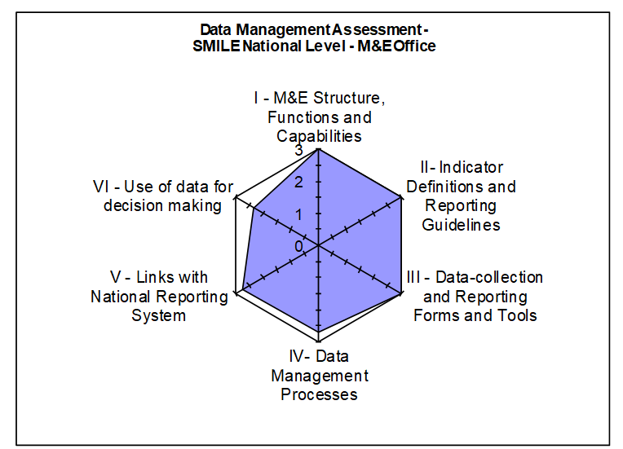

#### STRENGTHS – SMILE CENTRAL M&E UNIT

* Availability of trained M&E staff.
* Capacity building opportunity for SMILE M&E staff through the CRS LEARNS.
* Availability and use of an SOP to guide data management processes.
* Use of nationally approved NOMIS database.

#### areas for improvement – SMILE CENTRAL M&E UNIT

* There is no written policy to guide the storage period of source documents.
* Charts, graphs and maps that depict analyzed data were not sighted at the central M&E unit.

#### RECOMMENDATIONS – SMILE CENTRAL M&E UNIT

* Develop guidelines to inform the storage period of source documents and for inclusion in the data management SOP.
* Develop guidelines on data demand and use, for inclusion in the data management SOP and for dissemination to lower reporting levels.

### SMILE STATE-LEVEL M&E UNIT

#### M&E STRUCTURE, FUNCTIONS, AND CAPABILITIES

The SMILE state offices have designated M&E staff (M&E Officers), all of whom have received relevant training to carry out their assigned responsibilities. M&E staff at the SMILE Benue and Edo state offices received their last training in December 2017. The M&E Officers at SMILE state offices review the quality of the data in the reports received from CBOs prior to submission to the central SMILE office. When the M&E Officer is not available, a suitable backstop fills in the position. Feedback on the quality of reports received are provided to the CBOs via e-mails, phone calls and during visits. There were no major differences in the findings of the M&E structure, functions, and capabilities across the four state M&E units assessed.

#### INDICATOR DEFINITION AND REPORTING GUIDELINES

The four SMILE state offices had the PEPFAR MER indicator guide that defines the indicator and its method of calculation. In addition, the M&E activities of the state offices are guided by the SMILE data management SOP which include details on the reporting requirements and timelines.

#### DATA COLLECTION AND REPORTING FORMS AND TOOLS

The state M&E units aggregate data from NOMIS export files received from the CBOs. The states also ensure the availability and consistent use of the national OVC tools by the CBOs. As at the time of the DQA exercise, there was no stock out of reporting tools at the state offices. Instructions were provided to the states on utilization of the tools through the data management SOP and also during trainings and supervisory visits by the central level. The states also step down the utilization instructions for the reporting tools to the CBOs.

#### DATA MANAGEMENT PROCESSES

The states M&E Officers conduct regular data verification checks on CBO data before collation and submission to the central office. They also conduct data review meetings with the CBOs to discuss reported data.

All four state M&E units back-up data using hard drives while Nasarawa, Benue and Edo states back-up data using the cloud technology (Google Drive and OneDrive). The Edo state office backs-up data daily while both the Benue and Nasarawa states offices back-up data weekly. The storage period required for source documents is common knowledge to three state offices (Nasarawa, Benue and Edo) and known to be contained in the Memorandum of Understanding (MOU) between SMILE and the CBOs. The SMILE SOP for Data Management contains guidance on how activity documents ought to be archived.

#### LINKS WITH THE NATIONAL REPORTING SYSTEM

Indicator data generated at the four state offices have links with the National reporting system through data reported to both state Ministries of Women’s Affairs and Social Development (MWASD). Data are also reported by both state offices to the SMILE central office.

#### USE OF DATA FOR DECISION MAKING

The capacity of state M&E staff have been built to analyze data using charts and to disseminate same to various stakeholders for decision making during quarterly stakeholder meetings, conferences and workshops. The DQA team sighted evidence of data use only in the Nasarawa and Benue state offices. Data disseminated by the Nasarawa state office to the MWASD influenced the state government to create an OVC budget line in the state’s health budget. Also, data contained in the OVC Risk Assessment Form were used to identify beneficiaries at risk of HIV. These individuals were referred to nearby health facilities for HIV testing, care and treatment.

Figure 4, Figure 5, Figure 6, and Figure 7 show the spider graphs that display the M&E systems assessment for Benue, Edo, Nasarawa and the FCT respectively. Across the four states, it can be observed that the area on links with the national reporting system shows some gaps which is as a result of parallel reporting channels i.e., to government and donor agencies. However, there are mechanisms in place to harmonize reported data to both reporting entities such as the OVC program TWG meetings at the state level. The main area requiring improvement for Edo State and the FCT is in the use of data for decision making.

*Figure 4. Spider Graph of M&E Systems Assessment: SMILE Benue State*

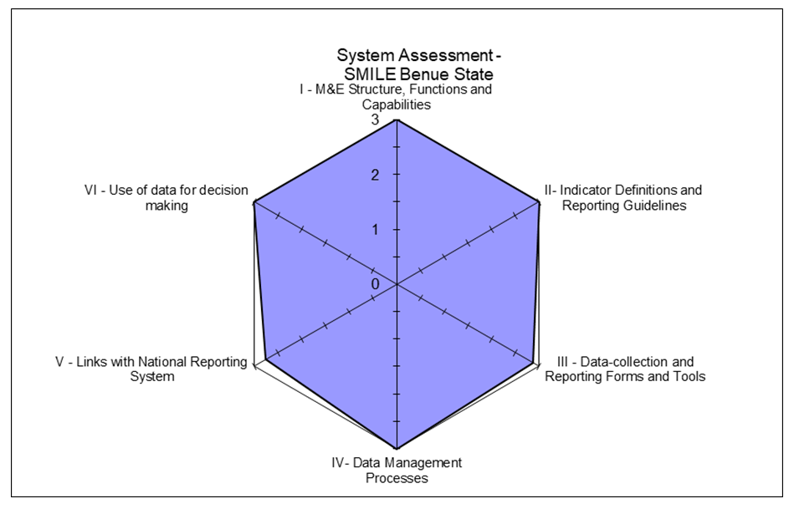

Figure 5: Spider Graph of M&E Systems Assessment: SMILE Edo State

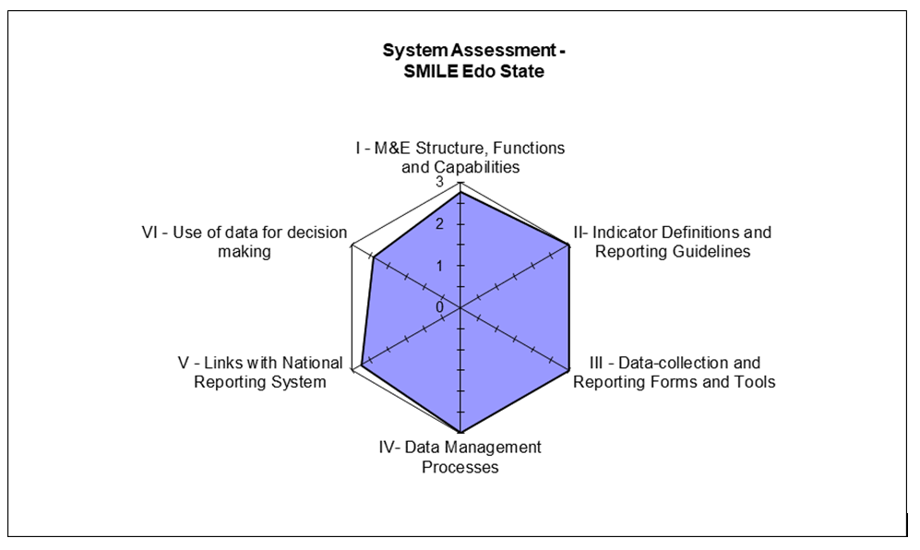

*Figure 6. Spider Graph of M&E Systems Assessment: SMILE Nasarawa State*

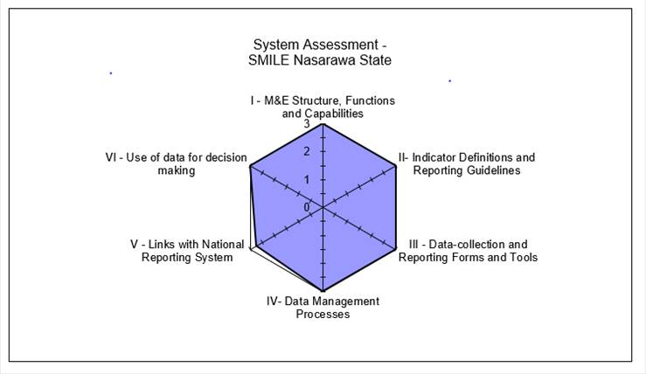

Figure 7: Spider Graph of M&E Systems Assessment: SMILE FCT

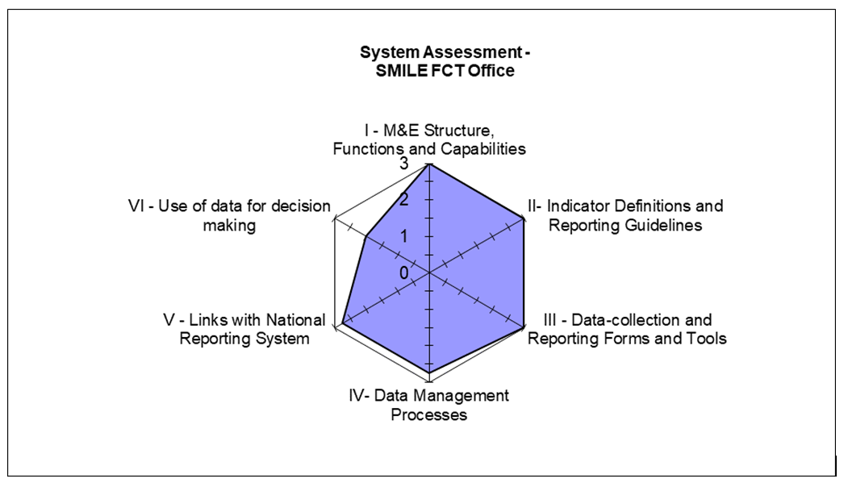

#### STRENGTHS – SMILE STATE LEVEL

* All state level M&E Officers have received relevant training to carry out their assigned responsibilities.
* All state offices have and use the SMILE SOP for data management, PIRS for the indicator being assessed, and are using the NOMIS database for reporting.
* State offices utilize multiple backup processes e.g. hard drive and cloud.
* Data are collated and presented in charts, tables etc. and disseminated to different stakeholders for decision making in Benue and Nasarawa states.

#### AREAS FOR IMPROVEMENT – smile state level

* The M&E staff at the FCT SMILE office were unaware of any policy guiding the storage period of source documents.
* There is little or no evidence of data use in Edo and FCT.

#### RECOMMENDATIONS - smile state level

* Develop a policy for inclusion in the data management SOP to guide the storage period of source documents.
* Obtain copies of data demand and use guidelines from the central M&E unit for implementation at the state M&E units.

### SMILE SERVICE DELIVERY LEVEL (CBOs)

A comparative M&E systems assessment for the twelve selected CBOs is presented below in narrative and tabular form, with details of the specific functional areas.

#### M&E STRUCTURE, FUNCTIONS, AND CAPABILITIES

At all the SMILE CBOs visited by the DQA team, it was observed that Community Volunteers (CV) enter beneficiaries’ information into the service delivery forms. The CV Supervisor collects all service delivery forms and reviews them for completeness before onward transmission to the CBO M&E Officer who also conducts data quality checks along with CBO Program Officers before the data are entered into the NOMIS by the Data Entry Clerk (DEC). CBOs receive regular feedback on data reported to the SMILE state M&E team via e-mails, phone calls, physical visits, DQAs and at TWG meetings.

All relevant staff within all the CBOs visited have received M&E training. Staff within five of the CBOs (IHPCD, EFFH, JDPC, GPI and FAHCI) received their last training in November 2017. In the absence of the M&E Officer, a staff of the CBO, trained in M&E (the DEC or the Program Officer) performs the role of the M&E Officer to ensure there are no gaps.

#### INDICATOR DEFINITION AND REPORTING GUIDELINES

All CBOs visited have the PEPFAR MER indicator guide for the OVC_HIVSTAT indicator. The SMILE data management SOP was also sighted and was in use across all the CBOs except at IHPCD where the team could not sight the indicator guide and the SOP. The DQA team sighted older versions of the PEPFAR MER indicator guide at three of the CBOs (GPI, DHSP and CACA) which calculates the OVC_HIVSTAT indicator differently.

The SMILE data management SOP contains guidelines on reporting requirements and timelines. Reporting timelines are also pasted on the walls of some of the CBOs visited for ease of reference.

#### DATA COLLECTION AND REPORTING FORMS AND TOOLS

Data collection tools and forms which include enrolment, OVC service and follow-up forms with clear instructions on use were available at all CBOs visited. National paper-based tools and the NOMIS database were consistently utilized during the period under review. Clear instructions on how to complete the tools were included in the SMILE SOP on data management which was available at the CBOs visited. All the CBOs had adequate supply of data collection tools except for Elohim Foundation. Request to replenish tools in short supply was not made due to the near close-out date of the SMILE IM.

#### DATA MANAGEMENT PROCESSES

Diverse methods were employed to ensure data quality and prevent double counting of indicator data at the CBOs. In this regard, the findings at the CBOs visited include:

1. Utilization of a built-in NOMIS function that identifies and removes duplicate values (100 percent of CBOs);
2. M&E staff review data and conduct periodic spots checks; and
3. Review of data quality during data review meetings (50 percent of CBOs).

CBOs utilized both local means and cloud technology to back-up data periodically. Complete details of data back-up methods for CBOs across the four states are provided in the Annex section 8.58.5 (Table 14).

In terms of maintaining confidentiality of beneficiary records, storage rooms and cabinets for beneficiary records were observed to be under lock and key. A confidentiality form has to be signed by non-CBO staff who wish to access beneficiary folders. However, at IHPCD, it was observed that beneficiary folders were stored in open filing cabinets, in a room with no lock. At EFFH, although the filing cabinet had locks, the hinges were coming off. The storage space for beneficiary folders at GPI was inadequate. Beneficiary folders were arranged horizontally at CWYCA, FAHCI and CBCSP, making retrieval of client records difficult. Three CBOs (JDPC, CSD and Elohim Foundation) did not have a written policy to guide the storage period of source documents.

#### LINKS WITH NATIONAL REPORTING SYSTEM

Indicator data generated at the CBOs have links with the National reporting system through data reported to respective LGA OVC focal persons, who in turn report to the State MWASD. Data are also reported by the CBOs within the states to respective SMILE state offices.

The NOMIS system clearly records information about where the services are rendered, using standardized naming conventions (e.g., state, LGA and ward) and the unique identification codes.

#### USE OF DATA FOR DECISION MAKING

All the CBOs reported that the M&E Officer analyzes data to develop charts, tables etc. for dissemination to various stakeholders. Four CBOs (JDPC, CWYCA, CBCSP and CSD) had their charts displayed on their office walls. Charts were not sighted at Elohim Foundation because the staff assigned with the task did not carry it out consistently. All CBOs disseminated findings from analyzed data and developed action plans for identified challenges at internal program team meetings, quality improvement team meetings, community improvement team meetings and monthly data review meetings attended by SMILE state office staff.

#### STRENGTHS – SMILE CBO LEVEL

* CBOs have trained M&E staff.
* Procedures are in place for data compilation and reporting when responsible staff are not available.
* The PIRS on the indicators, SOP for data management and national OVC reporting tools are available and in-use (at 92 percent of CBOs).
* The NOMIS software is being used and password protected.
* Beneficiary folders are stored under lock and key with limited access.
* Data are backed up routinely using external drive and the cloud.
* Data are analyzed and used for decision making.

#### AREAS FOR IMPROVEMENT – SMILE CBO LEVEL

* The PIRS for the indicator was not sighted at IHPCD.
* Old version of the PEPFAR MER indicator reference guide was sighted at GPI, DHSP and CACA.
* No policy available to guide the storage period of source documents at JDPC, CSD and Elohim Foundation.
* Inadequate storage space for beneficiary folders at GPI.
* Filing cabinet in need to repair at EFFH.
* Client folders were arranged horizontally at CWYCA, FAHCI and CBCSP, making retrieval of client records difficult.
* Confidentiality of beneficiary information not maintained at IHPCD because client folders are stored in an open filing cabinet within a room with no locks.

#### RECOMMENDATIONS – SMILE CBO LEVEL

* Disseminate the most updated version of the PEPFAR MER indicator guide version 2.2 to all CBOs and ensure compliance of CBOs to its use.
* Develop guidelines within the SOP for data management to guide the storage period of source documents.
* Provide adequate storage space for beneficiary folders at GPI.
* Provide storage cabinets with lock and key for beneficiary folders at IHPCD.
* Provide guidelines and technical assistance to CWYCA, FAHCI and CBCSP CBOs on the proper filing system of beneficiary folders (vertical arrangement) to aid quick retrieval of client records.
* Engage a vendor to repair damaged filing cabinet at EFFH.

## DATA QUALITY STANDARDS

### VALIDITY

Validity is the extent to which a measurement is well-founded and corresponds accurately to the real world. It pertains to measuring what is intended to be measured. Details of the DQA team’s review of data quality in the context of the OVC indicator are provided below.

#### DATA COLLECTION

The data, including HIV status are collected at the point of registration into the OVC activity, during provision of service and follow up visits using the “Vulnerable Children Enrollment Form,” “Vulnerable Children Service Form,” and “Vulnerable Children Follow-up Child Status Index (CSI) Form.” In addition, other tools such as the HIV test results, the HIV risk assessment results and other confidential, case management and monitoring tools are used to document the HIV status of beneficiaries. CVs enter services provided in the approved national tools, which are then collated and reviewed for accuracy and completeness by the CV Supervisor, before submission to the CBO M&E Officer. The CBO M&E Officer reviews and validates the data, before entry is made into the NOMIS by the DEC. Quality checks of data entries in the NOMIS are conducted by the CBO M&E Officer and the CBO Program Manager.

#### DOES THE DATA COLLECTED MEASURE WHAT IT IS SUPPOSED TO MEASURE?

As part of the OVC_HIVSTAT indicator, data collected include ‘total number of OVC less than 18 years with HIV status reported to IPs (including report of no status)’. The OVC_HIVSTAT indicator for SMILE matches the PIRS and is a direct measurement according to the standard indicator definition. The data collected by the IM measures total number of OVC less than 18 years who reported their HIV status including report of no status to SMILE. Data for this indicator are also collected as disaggregates to make up the whole: ‘Reported HIV positive to IP,’ ‘Reported HIV negative to IP,’ and ‘No HIV status reported to the IP.

#### UNDERSTANDING THE INDICATOR DEFINITION

The PIRS for the indicator was available at all the levels assessed, but not all CBOs had the most updated version of the PEPFAR MER indicator reference guide i.e. January 2018 release version 2.2.

#### DATA REPORTING

At the central M&E unit, all the indicator data reports from the states for the reporting period were available and complete. The re-aggregated OVC_HIVSTAT data at the central IP office, which were reported by the state offices completely matched the data submitted to USAID.

At the state M&E unit, all the indicator data reports from the CBOs for the reporting period were available and complete. The total OVC_HIVSTAT and disaggregate data reported by the CBOs to the states were verified and found to be 100 percent accurate for Edo, FCT and Nasarawa states, with the exception of Benue state (VF of 102 percent). Benue state’s underreporting was as a result of under-reporting of two of the indicator’s three disaggregates: ‘Reported HIV positive to the IP’ (VF of 119 percent) and ‘No HIV status reported to the IP’ (VF of 112 percent); and over-reporting of the third disaggregate- ‘Reported HIV negative to the IP’ (VF of 96 percent) (Figure 8) The Benue state M&E unit discovered the data discrepancies following a data clean-up exercise after the reporting period. The updated data will be reported to USAID within the next reporting cycle as an update to the previously reported data.

Figure 8.SMILE Benue State OVC_HIVSTAT Numerator Total and Disaggregates

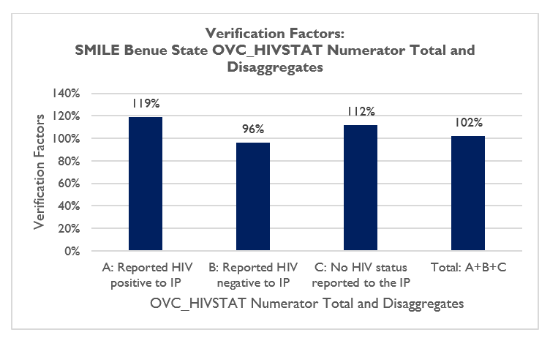

At the CBO level, all the indicator data reports from the CBOs for the reporting period were available, and complete. Out of the twelve CBOs visited in the four states, four CBOs had verified data which matched the data reported to the state level for all three disaggregates and the OVC_HIVSTAT total (JDPC, CACA, CWYCA and IHPCD). The remaining eight CBOs have either under-reported and/or overreported OVC_HIVSTAT total and/or disaggregate data asides two CBOs, GPI and EFFH, with 100 percent VF for the total OVC_HIVSTAT data, and disaggregate data with varying degrees of accuracy (Figure 9 and Table 13).

With consideration of the +/- ten percent acceptable variance for determining the accuracy of verified data, the global average of the verification factor for the OVC_SERV indicator across all the levels assessed falls between the allowed reporting variance of +/- ten percent (according to the MEASURE Evaluation RDQA tool), demonstrating that the data reported for the indicator by SMILE are valid for decision making (Figure 10).

Figure 9. Verification Factors: OVC_HIVSTAT Numerator Total for SMILE CBOS

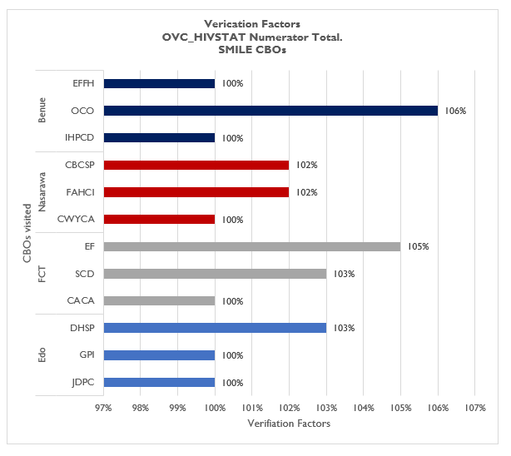

Figure 10. Data Verification by Level of Reporting System for SMILE

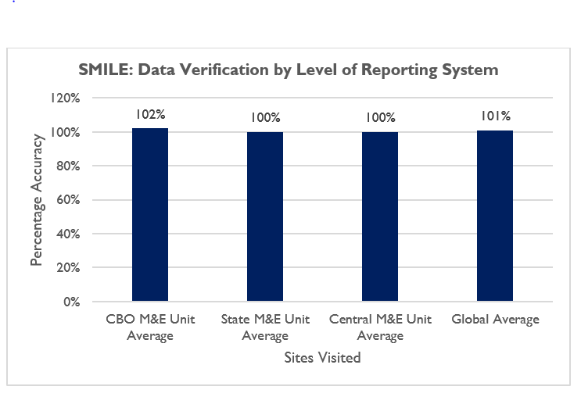

#### STRENGTHS

* Data for the OVC_HIVSTAT indicator are collected as stipulated by the indicator reference guide using national approved tools.
* The “HIV status update form” on the NOMIS is used to input and update the HIV status of the beneficiaries for accurate reporting.

#### VALIDITY ISSUES IDENTIFIED

Validity Issue 1: Transcription errors due to incomplete entries from the source documents to the NOMIS (Table 5):

* In ten out of twelve of CBOs visited (83.3 percent), transcription errors were identified during cross-checks from the source documents to the NOMIS. During the cross-checks from the NOMIS to source documents, transcription errors were identified in eleven out of twelve (91.5 percent) CBOs visited.
* Commonly observed reasons for mismatch in the cross-checks include:
  + - Incomplete or wrong entries into the NOMIS;
    - Incomplete or wrong entries into the enrolment form, client service form and follow up form.

*Table 5. Cross-Check Findings from SMILE CBOs in FCT, Edo, Benue and Nasarawa States*

|  |  |  |  |  |  |  |  |  |  |  |  |  |  |  |
| --- | --- | --- | --- | --- | --- | --- | --- | --- | --- | --- | --- | --- | --- | --- |
| **Cross Check Findings** | **FCT** | | | **Edo** | | | **Benue** | | | **Nasarawa** | | | **Total** | |
| **EF** | **SCD** | **CACA** | **DHSP** | **GPI** | **JDPC** | **IHPCD** | **EFFH** | **OCO** | **CWYCA** | **FAHCI** | **CBCSP** | **NO** | **%** |
| **Total cross checks: NOMIS to beneficiary folders and vice versa** | 20 | 20 | 20 | 20 | 20 | 20 | 20 | 20 | 20 | 22 | 20 | 20 | 242 |  |
| **Total cross checks by beneficiary forms** | 59 | 100 | 100 | 224 | 108 | 127 | 100 | 1004 | 104 | 106 | 113 | 101 | 1346 |  |
| **Number of beneficiary forms with incomplete, missing or wrong entries** | 3 | 5 | 6 | 5 | 3 | 4 | 0 | 24 | 0 | 3 | 5 | 4 | 62 | 5% |
| **Number of NOMIS entries that are incomplete, missing or wrong** | 2 | 4 | 7 | 8 | 2 | 3 | 1 | 15 | 0 | 3 | 6 | 2 | 53 | 4% |

Validity Issue 2**:** The DQA team noted errors during the data verification as detailed in the data reporting section above (4.2.1.4) and also in this section below:

Findings from recounted data aggregated at the CBOs varied from state to state as shown graphically in Figure 9. The numeric values for verification factors at state and CBO levels are shown in Annex sections Table 13. Reasons given for errors in data verification include:

* Initial poor understanding on the calculation of data for the indicator during the reporting period;
* Data updates following data clean-up after closure of the deadline for SAPR reporting. Four CBOs were observed to have reported updated data following the closure of the SAPR reporting deadline. Changes made to earlier reported data were documented using a CMP; and
* Data entry omissions.

#### RECOMMENDATIONS FOR IMPROVING DATA VALIDITY.

* Improve supervisory efforts with the CBOs to ensure accurate data entry and proper use of the NOMIS.
* Conduct refresher training for DECs on the NOMIS software.
* Build the capacity of CBO staff to accurately calculate the OVC_HIVSTAT indicator based on the updated indicator reference guide.

### RELIABILITY

#### MECHANISMS TO ENSURE DATA RELIABILITY

The SMILE IM utilized the National OVC reporting tools consistently during the period covered by this DQA. Data are retrieved on the indicator from the NOMIS and reported only as the number of OVC less than 18 years with HIV status reported to the IP (total and disaggregates). All SMILE CBOs and state-level reports for the period under assessment were available for review and complete along the same reporting format; as such, its data collection system remains reliable.

None of the CBOs experienced stock out of reporting tools within the period under assessment. At the state level, there was consistent use of the NOMIS aggregation and reporting platform. The NOMIS data export received monthly from CBOs by the stat M&E units are being aggregated and exported quarterly to the SMILE central office, using the NOMIS database. At the central level, data are extracted from NOMIS for reporting on the Data for Accountability, Transparency and Impact (DATIM) platform every SAPR reporting period.

#### STRENGTHS

* Consistent and uniform use of National reporting OVC tools.

#### AREAS FOR IMPROVEMENT

* None

#### RECOMMENDATION

* None

### PRECISION

#### MECHANISMS TO ENSURE DATA PRECISION

The data collected in the enrollment, service and follow-up forms are entered in the NOMIS in a consistent manner, and detailed level of information on the HIV status of the OVC less than18 years are reported. The nationally approved data fields in the forms are entered into the NOMIS. Since the NOMIS has household-level and individual-level data, it has sufficient detail and precision to provide information on HIV status of OVC less than 18 years, while ensuring that beneficiary confidentiality is protected. Data elements on the three forms have information fields such as date, sex, age, child HIV status, and services provided, which also have corresponding fields in the NOMIS. In addition, the NOMIS has data entry page that enables update of the HIV status of beneficiaries. The level of precision in the data collection forms and the NOMIS matches the requirements in the PIRS.

#### AREAS FOR IMPROVEMENT

* None

#### RECOMMENDATION

* None

### TIMELINESS

#### MECHANISMS TO ENSURE TIMELINESS

The IP staff at the SMILE central M&E unit reported that data are reported to USAID in a timely manner, and that state-level data are received in a timely manner through the NOMIS. The DQA team sighted email communications of received NOMIS data exports from lower reporting levels at the IP central and state offices. Reports were received from 52 CBOs covering 48 LGAs by the SMILE central office before the reporting deadline. However, at the state level, only the CBOs within the FCT reported timely during the period under assessment as shown in Figure 11. The CBOs in Benue, Edo and Nasarawa did not report timely during the period under review.

Figure 11. Reporting Performance – Results by State and Aggregate of States Result

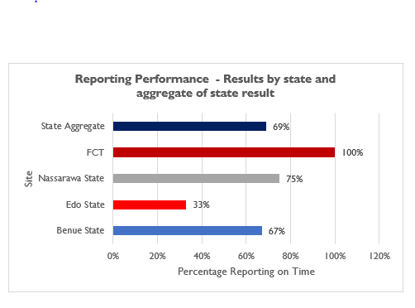

#### AREAS FOR IMPROVEMENT

* Untimely submission of reports from CBOs in Benue, Edo and Nasarawa States.

#### RECOMMENDATION

* Ensure compliance of CBOs to reporting timelines.

### INTEGRITY

#### MECHANISMS TO ENSURE INTEGRITY OF DATA

SMILE data collection and management process at the central IP level is through the NOMIS. Data validation processes executed by its M&E Director ensures that the data collated by SMILE undergoes data quality checks. At the state level, SMILE M&E Officers conduct data quality checks on data in the NOMIS platform. The password-protected NOMIS at all levels ensures confidentiality. Table 6 presents the mechanisms in use by SMILE to ensure integrity in activity implementation and data reporting.

It was observed that pencils were being used to fill reporting tools (service forms) at SCD CBO in the FCT.

*Table 6. Mechanisms for Ensuring Data Integrity across SMILE Sites*

|  |  |  |
| --- | --- | --- |
| **CENTRAL** | **STATE LEVEL** | **CBO LEVEL** |
| * Built-in checks in NOMIS that prevent double entries. * Cross check and review of data before reporting to USAID and government of Nigeria. | * Dedicated staff conducting quality checks. * Built-in checks in NOMIS that prevent double entries. * Cross-check of NOMIS entries. * Supervisory visits to CBOs. * Follow-up emails and phone calls to CBOs. | * The use of the password-protected NOMIS (100 percent). * Built-in checks in NOMIS that remove double entries (100 percent). * Dedicated staff to check for data quality (100 percent). * Limited access to the filing cabinet where source documents are kept. * Review data quality during data review meetings. |

#### STRENGTHS

* All the mechanisms outlined above are strengths in the M&E system of SMILE, to ensure the integrity of the indicator being assessed.

#### AREAS FOR IMPROVEMENT

* Use of pencils in filling reporting tools (service forms) at SCD CBO, within the FCT.

#### RECOMMENDATION

* Ensure CVs and all CBO staff discontinue the use of pencils in filling source documents.

# Action plan for SMILE

A suggested action plan for the various levels is outlined below, Table 7 – central level action plan, Table 8 – state level action plan and Table 9 – CBO level action plan.

## ACTION PLAN FOR SMILE CENTRAL LEVEL

*Table 7. Action Plan for SMILE Central Level*

|  |  |  |  |
| --- | --- | --- | --- |
| **Areas for Improvement** | **Description of Action Point** | **Responsible** | **Timeline** |
| SOP for data management does not include guidelines on the storage period of source documents. | Develop guidelines for inclusion in the data management SOP to inform the storage period of source documents. | SMILE M&E Director | September 2018 |
| Limited data demand and use. | * Develop guidelines on data demand and use and ensure its implementation across all levels. * Build the capacity of the Edo and FCT M&E team to analyze and use data for decision making. | SMILE M&E Director | September 2018 |

## ACTION PLAN FOR SMILE STATE LEVEL

*Table 8. Action Plan for SMILE State Level*

|  |  |  |  |
| --- | --- | --- | --- |
| **Areas for Improvement** | **Description of Action Point** | **Responsible** | **Timeline** |
| Old version of the PEPFAR MER indicator reference guide was sighted at some CBOs. | Disseminate the most updated version of the PEPFAR MER indicator reference guide version 2.2 to all CBOs and ensure compliance of CBOs to its use. | SMILE State M&E Officers | September 2018 |
| Client folders were arranged horizontally at some CBOs, and client forms were not arranged orderly within the folders, making retrieval of client records difficult. | Provide guidelines and technical assistance to CBOs on the proper filing system of beneficiary folders (vertical arrangement) and orderly arrangement of service forms within the folders, to aid quick retrieval of client records. | SMILE State M&E Officers | September 2018 |
| Errors observed in reported data during data verification. | * Improve supervisory efforts with the CBOs to ensure accurate data entry and proper use of the NOMIS. * Conduct refresher training for DECs on the NOMIS software. * Conduct refresher training for CBOs on the correct calculation of data elements for reporting on the OVC_HIVSTAT based on the updated indicator reference guide. | SMILE State M&E Officers | December 2018 |
| Untimely submission of reports by some CBOs in Benue, Edo and Nasarawa States. | Ensure compliance of CBOs to reporting timelines. | SMILE State M&E Officers | September 2018 |
| Use of pencils in filling reporting tools. | Improve supervisory efforts to CBOs to ensure staff discontinue use of pencils in filling source documents. | SMILE State M&E Officers | September 2018 |

## ACTION PLAN FOR SMILE CBO LEVEL

*Table 9. Action Plan for SMILE CBO Level*

|  |  |  |  |
| --- | --- | --- | --- |
| **Areas for Improvement** | **Description of Action Point** | **Responsible** | **Timeline** |
| Errors observed during data verification. | Improve supervisory efforts to DECs to improve accuracy of data entry into the NOMIS and of reported data to SMILE state office. | CBO M&E Officers | September 2018 |
| Inadequate storage space for beneficiary folders at GPI CBO. | Provide adequate storage space for beneficiary folders at GPI. | GPI SMILE Program Manager | September 2018 |
| Confidentiality of beneficiary information not maintained at IHPCD because client folders are stored in a room with no locks. | Provide storage space with lock and key for beneficiary folders at IHPCD. | IHPCD SMILE Program Manager | September 2018 |
| Filing cabinet in need to repair at EFFH. | Engage a vendor to repair damaged filing cabinet at EFFH. | EFFH SMILE Program Manager | September 2018 |

# Limitations and Constraints

1. DQAs at a country level are complex exercises and require significant resources and effort on the part of the commissioning agency, the agency conducting the DQA, IPs, and government functionaries in the relevant sectors. As mentioned in USAID’s “How-To Note: Conduct a DQA,”[5] notification of an impending DQA can also cause stress for the IP, given the ramifications of activity performance and the potential uncertainty of USAID’s expectations. Although the MEL Activity DQA team tried to allay initial apprehensions of the IP and its staff about the outcomes from the DQA, there may have been residual concerns that could not be fully addressed. The DQA team emphasized to the IP that subsequent to completion and dissemination of the final report, the DQA results are intended to be a tool for USAID and the IP to work together, to resolve any data quality issues or limitations discovered during the exercise.

2. The sampling of the four SMILE states, as well as the CBO sites visited in the states, was based on purposive methodology, with consideration to security and feasibility issues, and was also guided by USAID. The ideal sampling methodology would have been to use a statistically valid scientific method, as described in the MEASURE Evaluation DQA guidelines[6]. Implementation of a statistically valid method was constrained by security and other eligibility considerations outlined in section 3.1. This was partially compensated for by the number of CBOs covered during the DQA.

3. To ensure adequate time for the DQA teams in the field to complete all aspects of the DQA, including the M&E systems assessment, review of the data quality standards, data verifications, and cross-checks, a limited number of cross-checks were performed at each CBO (service delivery level). At most CBOs, at least twenty beneficiary folders were reviewed during the cross-checks. As described in detail in section 3.4.4, this limitation was partially addressed by using random selection of beneficiary folders (where feasible) from all household folders for the two reported quarters. Also, cross-checks were attempted in two directions—i.e., ten records were traced from the beneficiary forms/household folders to the NOMIS, and an additional ten unique beneficiary records were traced from the NOMIS back to the beneficiary folders for cross-verification.

# Conclusions

From the USAID/Nigeria and PEPFAR perspective, the DQA for OVC indicators serves to meet the operational policy requirements of USAID/Washington and USAID/Nigeria. It also serves to review the M&E system, identify best practices, and develop recommendations to improve existing systems, for better reporting of program indicators in subsequent funding cycles.

The SMILE IM has implemented some of the recommendations from the FY 2017 DQA on the OVC_SERV indicator, which has improved its M&E system e.g., distribution of the M&E SOP to all reporting levels and development of a training plan for the M&E staff. However, some of the areas noted for improvement during the FY 2017 DQA were still found to be a challenge during this FY 2018 DQA exercise e.g., hard copies of archived data submitted to all reporting entities with date stamps were still unavailable at assessment sites and the pencils were still being used to fill service forms at a CBO within the FCT.

The M&E system’s areas of strength across the three levels assessed include the availability of trained M&E staff with clearly assigned responsibilities, availability of a data management SOP that guides M&E processes and the capacity building opportunity provided for M&E staff through CRS LEANRS. The areas for improvement across the levels assessed include the need to improve data demand and use and the need to ensure that all reporting levels have, understand and use the most updated version PEPFAR MER indicator reference guide v2.2.

With reference to the ADS 201 definition of data quality standards (Table 1), the OVC_HIVSTAT indicator data reported by SMILE can be judged valid. Though data verification errors were observed at the service delivery and state office levels, the overall IP verification factor (global average) was 101 percent, which falls within the +/- ten percent acceptable variance for determining the accuracy of verified data (Figure 10). The validity of the SMILE indicator data can be improved by strengthening supervisory efforts at the state and CBO levels. IP reported data was found to be reliable. The timeliness of reported data can be improved on ensuring CBO compliance to reporting timelines while the integrity of reported data can be strengthened by ensuring CBO staff fill reporting tools with ink and not pencils.

USAID/Nigeria is recommended to establish a community of practice of NOMIS users to facilitate the identification of effective approaches to resolving the NOMIS software issues and data loss in NOMIS following data export and NOMIS software upgrade.

# Annexes

## LIST OF SITES VISITED AND LOCATIONS: SMILE DQA

A complete list of sites and locations visited is provided in section 3.2 and Table 3 of this report.

## STEPS FOR DATA VERIFICATION USING THE MEASURE EVALUATION TOOL

*Figure 12. Tracing and Verifying Reported Totals: CBO via State to Central M&E Unit*

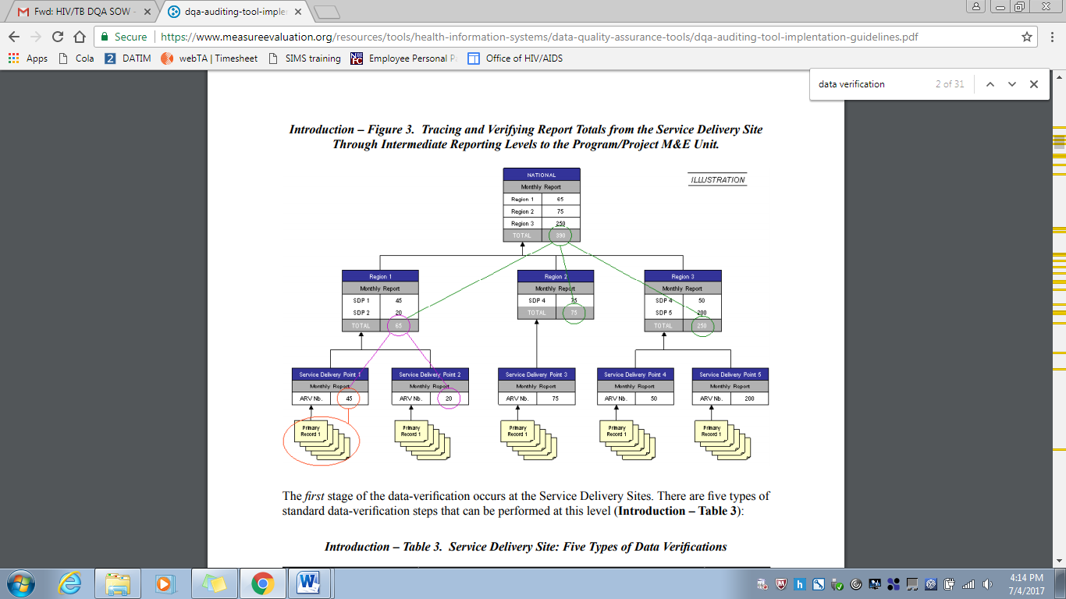

Source: MEASURE Evaluation (2008).

## VERIFICATION FACTORS – SMILE CENTRAL, STATE AND cbo LEVELS

Table 10. OVC_HIVSTAT Data at Central and State Levels

|  |  |  |  |  |  |  |  |  |  |
| --- | --- | --- | --- | --- | --- | --- | --- | --- | --- |
|  |  | VERIFIED DATA | | | | REPORTED DATA | | | |
| SITE NAME | **STATE/LGA** | **A: Reported HIV positive to IP** | **B: Reported HIV negative to IP** | **C: No HIV status reported to the IP** | **Total: A+B+C** | **A: Reported HIV positive to IP** | **B: Reported HIV negative to IP** | **C: No HIV status reported to the IP** | **Total: A+B+C** |
| SMILE HQ office | FCT | 3,119 | 161,632 | 64,789 | 229,540 | 3,119 | 161,632 | 64,789 | 229,540 |
| Edo IP State Office | Edo | 29 | 10,593 | 3,664 | 14,286 | 29 | 10,593 | 3,664 | 14,286 |
| FCT IP State Office | FCT | 578 | 22,409 | 9,068 | 32,055 | 578 | 22,409 | 9,068 | 32,055 |
| Nasarawa IP State Office | Nasarawa | 692 | 41,644 | 7,046 | 49,382 | 692 | 41,644 | 7,046 | 49,382 |
| Benue IP State Office | Benue | 2,129 | 71,615 | 46,250 | 119,994 | 1,786 | 74,783 | 41,134 | 117,703 |

Table 11. OVC_HIVSTAT Verification Factors at the Central and State levels

|  |  |  |  |  |  |
| --- | --- | --- | --- | --- | --- |
|  |  | VERIFICATION FACTORS | | | |
| SITE NAME | **STATE/LGA** | **A: Reported HIV positive to IP** | **B: Reported HIV negative to IP** | **C: No HIV status reported to the IP** | **Total: A+B+C** |
| SMILE HQ office | FCT | 100% | 100% | 100% | 100% |
| Edo IP State Office | Edo | 100% | 100% | 100% | 100% |
| FCT IP State Office | FCT | 100% | 100% | 100% | 100% |
| Nasarawa IP State Office | Nasarawa | 100% | 100% | 100% | 100% |
| Benue IP State Office | Benue | 119% | 96% | 112% | 102% |

Table 12. OVC_HIVSTAT Data at the CBO Level

|  |  |  |  |  |  |  |  |  |  |
| --- | --- | --- | --- | --- | --- | --- | --- | --- | --- |
|  |  | **VERIFIED DATA** | | | | **REPORTED DATA** | | | |
| **SITE NAME** | **STATE/LGA** | **A: Reported HIV positive to IP** | **B: Reported HIV negative to IP** | **C: No HIV status reported to the IP** | **Total: A+B+C** | **A: Reported HIV positive to IP** | **B: Reported HIV negative to IP** | **C: No HIV status reported to the IP** | **Total: A+B+C** |
| Justice Development and Peace Commission (JDPC), Catholic Diocese of Uromi | Edo/Esan North East | 4 | 1,948 | 361 | 2,313 | 4 | 1,948 | 361 | 2,313 |
| Girls Power Initiative (GPI) | Edo/Oredo | 9 | 1,385 | 944 | 2,338 | 7 | 667 | 1,673 | 2,347 |
| Department of Health Service Providers (DHSP), Catholic Archdiocese of Benin | Edo/Ikpoba-Okha | 5 | 2,442 | 112 | 2,559 | 4 | 2,160 | 328 | 2,492 |
| Catholic Action Committee on HIV/AIDS (CACA), Archdiocese of Abuja | FCT/Bwari | 241 | 5,848 | 1,554 | 7,643 | 241 | 5,848 | 1,554 | 7,643 |
| Society for Community Development (SCD) | FCT/AMAC | 19 | 7,011 | 2,196 | 9,226 | 38 | 6,137 | 2,787 | 8,962 |
| Elohim Foundation (EF) | FCT/  Gwagwalada | 193 | 6,185 | 1,057 | 7,435 | 212 | 5,559 | 1,323 | 7,094 |
| Centre for Women Youth and Community Action (CWYCA) | Nasarawa  /Nasarawa Eggon | 146 | 5,804 | 286 | 6,236 | 146 | 5,804 | 286 | 6,236 |
| Family Health Care Foundation (FAHCI) | Nasarawa/Lafia | 100 | 6,495 | 2,823 | 9,418 | 177 | 7,924 | 1,131 | 9,232 |
| Community Based Care and Support Program, Catholic Diocese of Lafia (CBCSP) | Nasarawa/  Akwanga | 37 | 3,747 | 44 | 3,828 | 39 | 3,697 | 2 | 3,738 |
| Integrated Health Program, Catholic Diocese of Makurdi (IHPCD) | Makurdi | 79 | 3,860 | 11,242 | 15,181 | 79 | 3,860 | 11,242 | 15,181 |
| Otabo Caregivers Otukpo Benue (OCO) | Otukpo | 24 | 4,203 | 0 | 4,227 | 38 | 3,944 | 0 | 3,982 |
| EFA-Eying Foundation for Family Health (EFFH), Vandeikya Benue | Vandekiya | 19 | 726 | 3,741 | 4,486 | 29 | 4,138 | 341 | 4,508 |

Table 13. OVC_HIVSTAT Verification Factors at the CBO level

|  |  |  |  |  |  |
| --- | --- | --- | --- | --- | --- |
|  |  | **VERIFICATION FACTORS** | | | |
| **SITE NAME** | **STATE/LGA** | **A: Reported HIV positive to IP** | **B: Reported HIV negative to IP** | **C: No HIV status reported to the IP** | **Total: A+B+C** |
| Justice Development and Peace Commission (JDPC), Catholic Diocese of Uromi | Edo/Esan North East | 100% | 100% | 100% | 100% |
| Girls Power Initiative (GPI) | Edo/Oredo | 129% | 208% | 56% | 100% |
| Department of Health Service Providers (DHSP), Catholic Archdiocese of Benin | Edo/Ikpoba-Okha | 125% | 113% | 34% | 103% |
| Catholic Action Committee on HIV/AIDS (CACA), Archdiocese of Abuja | FCT/Bwari | 100% | 100% | 100% | 100% |
| Society for Community Development (SCD) | FCT/AMAC | 50% | 114% | 79% | 103% |
| Elohim Foundation (EF) | FCT/Gwagwalada | 91% | 111% | 80% | 105% |
| Centre for Women Youth and Community Action (CWYCA) | Nasarawa/Nasarawa Eggon | 100% | 100% | 100% | 100% |
| Family Health Care Foundation (FAHCI) | Nasarawa/Lafia | 56% | 82% | 250% | 102% |
| Community Based Care and Support Program, Catholic Diocese of Lafia (CBCSP) | Nasarawa/Akwanga | 95% | 101% | 2200% | 102% |
| Integrated Health Program, Catholic Diocese of Makurdi (IHPCD) | Makurdi | 100% | 100% | 100% | 100% |
| Otabo Caregivers Otukpo Benue (OCO) | Otukpo | 63% | 107% | 100%- | 106% |
| EFA-Eying Foundation for Family Health (EFFH), Vandeikya Benue | Vandekiya | 66% | 18% | 1097% | 100% |

## DIAGRAMMATIC REPRESENTATION OF CROSS-CHECKS AT CBO LEVEL

*Figure 13. Methodology for Cross-Checks at CBO Level*

**OVC CROSS CHECK AT CBO**

CROSS CHECK 1

CROSS CHECK 2

Select 10 enrolment numbers and unique identifiers within the reporting period from the NOMIS

Select 10 beneficiary service forms (randomly where feasible) within the reporting period from 10 folders (using enrolment number and unique identifiers)

Confirm enrollees in NOMIS have 10 corresponding service forms

Confirm 10 enrollees are present on the NOMIS

Trace and Find Corresponding Entries and Compare in the NOMIS

Trace and Find Corresponding Entries and Compare in the Service Forms

## DATA BACKUP MECHANISMS IN BENUE, EDO, NASARAWA AND FCT CBOs

*Table 14. Data Backup Mechanisms Utilized Across SMILE Sites Visited*

|  |  |  |  |  |  |  |  |  |  |  |  |
| --- | --- | --- | --- | --- | --- | --- | --- | --- | --- | --- | --- |
| **Name of CBO** | **State** | **Backup Mechanism Utilized** | | | | | | | |  | **Timeline** |
| Cloud Based | | | | Hard Drive | Flash Drive | Official Laptops | Personal devices | C. drive |  |
| Unspecified | OneDrive | Google Drive | Drop Box |  |  |  |  |  |  |
| **JDPC, Catholic Diocese of Uromi** | Edo |  |  |  |  | √ |  |  |  |  | Monthly |
| **GPI** | Edo | √ |  |  |  | √ |  |  |  |  | Monthly |
| **DHSP** | Edo |  |  |  |  | √ |  |  |  |  |  |
| **CACA, Archdiocese of Abuja** | FCT |  |  |  |  | √ |  | √ |  |  | Every 2 Weeks & Monthly |
| **SCD** | FCT |  |  |  |  | √ |  | √ |  |  | Weekly |
| **Elohim Foundation** | FCT |  |  |  |  | √ |  |  |  |  |  |
| **CWYCA** | Nasarawa |  |  | √ |  | √ |  |  |  |  | Weekly |
| **FAHCI** | Nasarawa |  |  | √ |  | √ |  |  |  |  | Weekly & Monthly |
| **CBCSP** | Nasarawa |  |  | √ |  | √ |  |  |  |  | Monthly |
| **IHPCD** | Benue | √ |  |  |  | √ |  |  |  |  | Weekly |
| **Otabo Caregivers Otukpo** | Benue |  |  |  |  | √ |  |  |  |  | Monthly |
| **EFFH, Vandeikya** | Benue | √ |  |  |  | √ |  |  |  |  | Monthly |

## PERFORMANCE INDICATOR REFERENCE SHEET (PIRS)

|  |  |  |  |  |
| --- | --- | --- | --- | --- |
| **OVC_HIVSTAT** | | | | |
| Description: | Percentage of orphans and vulnerable children (<18 years old) with HIV status reported to implementing partner (including report of no status). | | | |
| Numerator: | Number of orphans and vulnerable children (<18 years old) with HIV status reported to implementing partner, disaggregated by status type. | | Data sources for this indicator include HIV test results that are self-reported by OVC (or their caregivers), results of HIV Risk Assessments conducted by implementing partners, registers, referral forms, client records, or other confidential case management and program monitoring tools that track those in treatment and care. | |
| Denominator: | Number of orphans and vulnerable children reported under OVC_SERV (<18 years old) | | Denominator is not collected again, as part of this indicator but is collected under the indicator OVC_SERV. | |
| Changes in indicator: | • This indicator formerly called OVC_ACC (MER 1.0) and OVC_KNOWNSTAT (in the original MER 2.0 target setting documentation guidance) was changed to OVC_HIVSTAT to reflect that HIV status is self- reported to the implementing partner by the OVC or OVC caregiver (MER 1.0 to MER 2.0). | | | |
| How to use: | |  | | --- | | This indicator will be tracked through routine program monitoring semi- annually through the POART process.  Given the elevated risk of HIV infection among children affected by and vulnerable to HIV, it is imperative for PEPFAR implementing partners to monitor HIV status among OVC beneficiaries, and to facilitate access and retention in ART treatment for those who are HIV positive. When the implementing partner knows the HIV status, the program can contribute to ensuring that the children are linked to appropriate care and treatment services, all essential elements of quality case management. OVC programs can also play an important role in family-centered disclosure, for those who are HIV positive.  • This indicator is NOT intended to be an indicator of HIV tests performed or receipt of testing results, as these are measured elsewhere and test results are frequently unavailable to community organizations due to health facility concerns about patient confidentiality.  • This indicator is NOT intended to imply that all OVC beneficiaries require an HIV test. OVC with known positive or negative status do not need to be tested. Only OVC with no HIV status or children reported to be negative and recently experiencing sexual violence and/or other risk factors in the reporting period should be assessed for HIV risk. For older children who the IP thinks may be sexually active, they should be assessed every reporting period.  • Status disclosure to the implementing partner is NOT a prerequisite for enrolment or continuation in an OVC program. OVC programs serve persons of positive, negative, and unknown HIV status appropriate to their needs and vulnerability to HIV. This indicator ensures that IPs are regularly providing outreach to caregivers to identify children’s HIV status, encourage family disclosure and linkage to care and treatment as needed.  • This indicator captures if implementing partners are tracking the self-reported HIV status of the orphans and vulnerable children they serve and enrolment in ART for those who are positive. Testing results for OVC who are referred for testing should be reported under HTS_TST based on the service delivery point where they were tested  This indicator also captures if implementing partners are tracking if the orphans and vulnerable children they serve who report to be HIV positive are successfully linked to and retained in treatment and care.  • This indicator is a subset from OVC_SERV. Only OVC who were reported under OVC_SERV <18 should be included in the denominator for this indicator.  • Since this is not a testing indicator, HIV positivity yield should NOT be calculated based on this indicator. Yield calculations should only be made by testing partners. | | | | |
| How to collect: | Data sources for this indicator include HIV test results that are self-reported by OVC (or their caregivers), results of HIV Risk Assessments conducted by implementing partners, registers, referral forms, client records, or other confidential case management and program monitoring tools that track those in treatment and care.  Implementation of the HIV risk assessment should be integrated into case management and on-going case monitoring and should not be conducted separately, if possible. This will vary by partner and project. The partners should work out a timeline based on their experience of how long referral completion and status disclosure usually takes and factor that into their case management processes.  Implementing partners will record the OVC beneficiary’s self-reported HIV status –semi-annually. | | | |
| Reporting level: | Facility & Community | | | |
| How often to report: | Semi-Annual | | | |
| How to review for data quality: | The OVC_HIVSTAT total numerator should ideally equal OVC_SERV<18 results. In some cases, there may be missing data for the following reasons: 1) IP was not able to collect this information from all caregivers of OVC_SERV<18 within the reporting period, 2) IP was not able to locate all the caregivers of OVC_SERV<18 (e.g., relocated, migrant work), 3) data entry error and/or 4) Peace Corps is currently not reporting on this indicator so OVC served <18 under PC would be missing.  Review any site with the following reporting issues: 1) numerator greater than 100% of OVC_SERV <age 18, 2) very low coverage of OVC_HIVSTAT, 3) sum of “Currently on ART” and “Not currently on ART” do no equal the “Reported HIV positive to IP” results and 5) sum of “Test not indicated” and “Other reasons” do not equal “Reported No Status to IP”. | | | |
| How to calculate annual total: | Use result reported at Q4. | | | |
| Data elements (components of indicator): | Numerator:  Number of orphans and vulnerable children (<18 years old) with HIV status reported to implementing partner, disaggregated by status type. | Disaggregate Groups | | Disaggregates |
| Status Type  [Required] | | • Reported HIV positive to implementing partner  o Currently receiving ART  o Not currently receiving ART  • Reported HIV negative to implementing partner  • No HIV status reported to the implementing partner  o Test not indicated based on HIV risk assessment  o Other reasons |
| Disaggregate Descriptions & Definitions | | | |
| Status Type Disaggregate Definitions:  “Reported HIV Positive to IP”: includes beneficiaries <age 18 who report to the IP that they are HIV positive based on an HIV test conducted during or prior to the reporting period (regardless of where the test occurred). All entries for “reported HIV positive to IP” should be further disaggregated as “currently receiving ART” or “not currently receiving ART.” This also includes beneficiaries <age 18 who report that they are HIV positive based on an HIV test conducted during previous project reporting periods. OVC entered as “Reported HIV positive to IP” in the previous reporting period, should continue to be reported as positive during the current reporting period and their enrolment in ART noted.  • “Reported HIV negative to IP” includes beneficiaries <age 18 who report that they are HIV negative to the IP based on an HIV test conducted during the reporting period (regardless of where the test occurred). For a child who reports multiple tests within the current period, use most recent test. For beneficiaries entered as “Reported HIV negative to IP” in a previous reporting period—if the IP believes the child’s risk has not changed in the last six months, they should continue to report the child as negative during the current reporting period. However, if the IP believes that the child has recently been exposed to risk of HIV infection (e.g., sexual violence) or if an adolescent has become sexually active, then the IP should conduct the HIV risk assessment. Potential outcomes reported after the HIV risk assessment include 1) the child is tested and reported as HIV positive and either currently receiving ART or not receiving ART, or 2) the child is tested and reported as HIV negative, or 3) the child is reported as “No Status” and under one of its disaggregates (“Test not indicated” or “Other reasons”).  • “No HIV status reported to the IP” includes beneficiaries who fall into one of the below described categories:  • “Test not indicated” – includes beneficiaries (OVC_SERV<age 18) who based on a risk assessment made by the implementing partner do not require a test during the reporting period. (Consensus Conference Technical Report on the Role of OVC Programs Supported by PEPFAR in Extending Access to HTS includes further information on determining whether a test is indicated)  • “Other reasons” – includes all beneficiaries (OVC_SERV <age 18) not entered in above categories. Potential scenarios included in other reasons include:  i. Caregiver refuses to disclose whether the child has been tested and his/her current HIV status in the reporting period  ii. Caregiver refuses to let the IP conduct a risk assessment on the child in the reporting period.  iii. Caregiver recommended by IP to have child tested base on risk assessment, but refuses to test the child in the reporting period OR does take child to test but doesn't report results to IP in the reporting period.  iv. The IP is still in the process of convincing the caregiver to get the child assessed, tested and/or disclosure of status. Since this is a new indicator and takes time, IPs may not be positioned to report within the reporting period and would be captured under – Undisclosed to IP - Other Reasons. The IP should monitor these children and provide services to encourage referral completion and disclosure in the next reporting period.  • Children entered as “No HIV status reported to the IP” with the disaggregate “Other reasons” in the previous reporting period should receive follow-up services to encourage referral completion/disclosure of status to the IP. Children reported as “No HIV Status to the IP” with the disaggregate “Test not indicated” with no changes in their risk situation for past six months, don’t need to be reassessed. If the IP believes the child’s risk situation has changed in the last six months, then the child should be reassessed by the implementing partner to determine whether testing is indicated and the results entered as outline above, and the child should receive appropriate follow-up | | | |
| PEPFAR-support definition: | Standard definition of DSD and TA-SDI used.  Provision of key staff or commodities for OVC beneficiaries receiving care and support services in the community include: For beneficiaries of OVC services, this can include funding of salaries (partial or full) for staff of the organization delivering the individual, small group or community level activity (e.g., psychosocial support, child protection services, education, etc.) or procurement of critical commodities essential for ongoing service delivery. Partial salary support may include stipends or incentives for volunteers, or paying for transportation of those staff to the point of service delivery.  For care and support services, ongoing support for OVC service delivery for improvement includes: the development of activity-related curricula, education materials, etc., supportive supervision of volunteers, support for setting quality standards and/or ethical guidelines, and monitoring visits to assess the quality of the activity, including a home visit, a visit to a school to verify a child’s attendance and progress in school or observation of a child’s participation in kids clubs. | | | |
| Guiding narrative questions: | For OVC_HIVSTAT, if less than 100% of caregivers have reported their child's status, please explain the percentage that have not reported to the IP their child's status and the plan to get closer to 100% coverage. Are there certain partners that are struggling and how the Mission is responding?  2. For children reported as not currently on ART, what are efforts are being undertaken in response? Are there certain partners with low ART coverage, why?  3. Please explain the breakdown of those reported under No Status. What percentage were: 1) risk assessed and reported as test not indicated and 2) test indicated, 3) caregivers unwilling to disclose status; 4) incomplete referrals for testing; 5) Other reasons (please specify). | | | |

## LIST OF DOCUMENTS, DATA, AND STANDARD OPERATING PROCEDURES REVIEWED

### LIST OF SMILE DATA AND DOCUMENTS REVIEWED

1. SMILE CBO FY 2018 SAPR reports.
2. SMILE state office FY 2018 SAPR reports.
3. SMILE central office FY 2018 SAPR report.
4. FY18 SAPR report submitted to USAID via DATIM.

### LIST OF SMILE REPORTING TOOLS REVIEWED

1. VC enrollment register.
2. VC enrollment form.
3. OVC service form.
4. Child follow-up assessment form.
5. HIV risk assessment form.
6. HIV test results form.

### LIST OF SMILE SOP/GUIDELINES AND OTHER DOCUMENTS REVIEWED

1. Performance Indicator Reference Sheet (PIRS) – PEPFAR MER 2.0 Version 2.2.
2. M&E training reports.
3. SMILE SOP for data management.
4. SMILE brief, August 2018.
5. Protocol for FY18 HIV OVC DQA.
6. SMILE FY 2017 DQA report.
7. SMILE FY 2017 follow-up DQA report.

## LIST OF INDIVIDUALS INTERVIEWED DURING THE SMILE DQA

Note: For meaning of the acronyms, please refer to acronym list (page V).

*Table 15. List of Individuals Interviewed during the SMILE DQA*

|  |  |  |  |  |  |
| --- | --- | --- | --- | --- | --- |
| **S. No.** | **Name** | **Location** | **Title** | **State** | **Level** |
| 1 | Stanley Amadiegwu | CRS Office | Director of M&E | FCT | Central |
| 2 | Nsobundu Chigozie | CRS-SMILE | Technical Officer M&E |  |  |
| 3 | Ogundipe Akinwale | CRS Office | M&E Manager | FCT | State |
| 4 | Oke Olufemi | CRS_SMILE | Senior Technical Specialist -HIV, Care and Support | FCT | State |
| 5 | Ugwunne Blessing | CRS_SMILE | Monitoring, evaluation, Adaptation and Learning Assistance | FCT | State |
| 6 | Brown Queen | CACA | Care & Support Officer | FCT | CBO |
| 7 | Onyeachonam. N. Modester | CACA | Data Clerk | FCT | CBO |
| 8 | Ogbile James | CACA | Data Clerk | FCT | CBO |
| 9 | Chito Obiora | CACA | Program Manager | FCT | CBO |
| 10 | Ojokyo Anthonia | SCD | Program Manager | FCT | CBO |
| 11 | Amucha Oluchi | SCD | Data Clerk | FCT | CBO |
| 12 | Idaewoh O. Paul | SCD | Vulnerable Children (VC) Officer | FCT | CBO |
| 13 | Joseph Imafidon | SCD | M&E | FCT | CBO |
| 14 | Lilian E. J. Godfrey | Elohim Foundation | Program Manager | FCT | CBO |
| 15 | Owoaka Sason | Elohim Foundation | M & E | FCT | CBO |
| 16 | Joy Opara | Elohim Foundation | Vulnerable Children Officer | FCT | CBO |
| 17 | Ibecheole Ugochukwu | Elohim Foundation | Data Clerk | FCT | CBO |
| 18 | Sontyo Jimi | CRS-SMILE | M&E Manager | Benue | State |
| 19 | Amusan-Ikpa Susanna | CRS-SMILE | Technical Specialist, Health Care and Support | Benue | State |
| 20 | Francis Osazuwa | CRS-SMILE | Finance and Admin | Benue | State |
| 21 | Ngusha Ayator.N. | CRS-SMILE | Technical Officer M&E | Benue | State |
| 22 | Ameh O. Sanchuse | CRS-SMILE | Program Officer | Benue | State |
| 23 | Ehiemere Charles.C. | CRS-SMILE | Technical Officer HES/Food and Support | Benue | State |
| 24 | Patricia Ogwuche | CRS-SMILE | Technical Officer Nutrition | Benue | State |
| 25 | Nwaogwugwu Amarachi | CRS-SMILE | M&E Assistant | Benue | State |
| 26 | Omaba Davidson | Otabo Caregivers | Data Clerk | Benue | CBO |
| 27 | William Ede | Otabo Caregivers | HES Officer | Benue | CBO |
| 28 | Idoko Benjamin | Otabo Caregivers | Data Clerk | Benue | CBO |
| 29 | Abbah Divine | Otabo Caregivers | Staff | Benue | CBO |
| 30 | Mary Amana | Otabo Caregivers | Nutrition Officer | Benue | CBO |
| 31 | Agbo Helen | Otabo Caregivers | Care & Support Officer | Benue | CBO |
| 32 | Ugwu Martins Chinedu | Otabo Caregivers | Corper | Benue | CBO |
| 33 | Christiana Oga | Otabo Caregivers | Chief Executive Officer (CEO) | Benue | CBO |
| 34 | Agaba Mohammed | Otabo Caregivers | M&E OFFICER | Benue | CBO |
| 35 | Ogah Anthony Owabo | Otabo Caregivers | Program Manager | Benue | CBO |
| 36 | Attah Isaac | Otabo Caregivers | Staff | Benue | CBO |
| 37 | Esoso Ayambem.A. | EFFH | Program Manager | Benue | CBO |
| 38 | Ate Phoebe | EFFH | Nutrition Officer | Benue | CBO |
| 39 | Eyeh Anah.E. | EFFH | Care and Support (C&S) Officer | Benue | CBO |
| 40 | Enyeme Neku.M. | EFFH | M&E Officer | Benue | CBO |
| 41 | Chukwukere Adolphus | EFFH | HES Officer | Benue | CBO |
| 42 | Nsed Ayam Nsed | EFFH | VC Officer | Benue | CBO |
| 43 | Akpe Isaiah | IHPCD | Data Clerk | Benue | CBO |
| 44 | Ukula Gabriel | IHPCD | M&E Officer | Benue | CBO |
| 45 | Du Gerald Ngutor | IHPCD | HES Officer | Benue | CBO |
| 46 | Ikpeekor Fidelis | IHPCD | Program Manager | Benue | CBO |
| 47 | Aza Teryila | IHPCD | Data Clerk | Benue | CBO |
| 48 | Shehu Alhassan | IHPCD | Data Clerk | Benue | CBO |
| 49 | Bashiru Ahmed | CRS SMILE | M & E Officer | Edo | State |
| 50 | Emmanuel Imorame | DHSP | M&E | Edo | CBO |
| 51 | Ezeanyim Kemi | DHSP | Project Manger | Edo | CBO |
| 52 | Obasogie Christopher | DHSP | C&S Officer | Edo | CBO |
| 53 | Onolumenosen Godday | DHSP | HES Officer | Edo | CBO |
| 54 | Igboanusi Solomon | DHSP | Data Entry Clerk | Edo | CBO |
| 55 | Edobar Harrison | GPI Benin | Data Clerk | Edo | CBO |
| 56 | Amadasun Ese | GPI Benin | M&E | Edo | CBO |
| 57 | Ayo Amen Ediae | GPI Benin | Project Manager | Edo | CBO |
| 58 | Ose D. | JDPC | M&E Officer | Edo | CBO |
| 59 | Iyorioshe Michael | JDPC | Program Manger | Edo | CBO |
| 60 | Seli C. | JDPC | Data Clerk | Edo | CBO |
| 61 | Paul Nwaonye | SMILE – CRS | Technical Officer/M and E | Nasarawa | State |
| 62 | Prince O Ezekiel | SMILE – CRS | MEAL Assistant | Nasarawa | State |
| 63 | Olashore Emmanuel | SMILE – CRS | TS – TB | Nasarawa | State |
| 64 | Awotunde Williams | SMILE – CRS | Program Manager | Nasarawa | State |
| 65 | Sr Jovita Egwu | CBCSP | Executive Director/Administrator | Nasarawa | CBO |
| 66 | Samuel Abimiku | CBCSP | M and E Officer | Nasarawa | CBO |
| 67 | Danjuma Peter Dardel | CBCSP | HES Officer | Nasarawa | CBO |
| 68 | Sogotbial Victoria N | CBCSP | Nutrition Officer | Nasarawa | CBO |
| 69 | Ayiwulu A Jessice | CBCSP | Data Clerk | Nasarawa | CBO |
| 70 | Joseph A Bamayi | CBCSP | C and S Officer | Nasarawa | CBO |
| 71 | Jatau N Francis | CBCSP | Data Clerk | Nasarawa | CBO |
| 72 | Mary Noktiuk Ashenanye | FAHCI | Executive Director | Nasarawa | CBO |
| 73 | Timothy David | FAHCI | VC Officer | Nasarawa | CBO |
| 74 | Obunri Esla | FAHCI | M and E Officer | Nasarawa | CBO |
| 75 | Katyar Tougkan | FAHCI | Project Manager | Nasarawa | CBO |
| 76 | Fawin Juna | FAHCI | Care and Support Officer | Nasarawa | CBO |
| 77 | Blessing A Yohanna | FAHCI | Nutrition Officer | Nasarawa | CBO |
| 78 | Bulus Efuna Eyona | FAHCI | Data Clerk | Nasarawa | CBO |
| 79 | Oyey Jacob Anzaku | FAHCI | Data Clerk | Nasarawa | CBO |
| 80 | Atakyun Alfred Alaku | FAHCI | Data Clerk | Nasarawa | CBO |
| 81 | Itari Aliyu | NACWYCA | Data Clerk 1 | Nasarawa | CBO |
| 82 | Everister Daniang | NACWYCA | C and S Officer | Nasarawa | CBO |
| 83 | Jacob Bulus Baju | NACWYCA | Data Clerk 2 | Nasarawa | CBO |
| 84 | Martha Jacob | NACWYCA | Nutrition Officer | Nasarawa | CBO |
| 85 | Adebiyi Afolasade | NACWYCA | H.E.S Officer | Nasarawa | CBO |
| 86 | Ihuoma Ozioma | NACWYCA | VC Officer | Nasarawa | CBO |
| 87 | Dokpa Mamman | NACWYCA | M and E Officer | Nasarawa | CBO |

1. MEASURE Evaluation. Data Quality Assurance Tools: DQA and RDQA Toolkit (Internet). Available from: <https://www.measureevaluation.org/resources/tools/health-information-systems/data-quality-assurance-tools>
2. ADS 201 Additional Help. USAID Recommended Data Quality Assessment (DQA) Checklist. Available from: <https://www.usaid.gov/sites/default/files/documents/1865/201sae.pdf>
3. MEASURE Evaluation. Data Quality Assurance Tools: DQA and RDQA Toolkit (Internet). Available from: https://www.measureevaluation.org/resources/tools/health-information-systems/data-quality-assurance-tools
4. ADS 201 Additional Help. USAID Recommended Data Quality Assessment (DQA) Checklist. Available from: <https://www.usaid.gov/sites/default/files/documents/1865/201sae.pdf>
5. USAID. How-To Note: Conduct a Data Quality Assessment [Internet]. 2017. Available from: https://usaidlearninglab.org/sites/default/files/resource/files/cleared_-_how-to_note_-_conduct_a_dqa.pdf
6. MEASURE Evaluation. Data Quality Audit Tool: Guidelines for Implementation [Internet]. 2008. Available from: <https://www.measureevaluation.org/resources/publications/ms-08-29>